NSW Education Standards Authority | 
Mathematics Advanced 11–12 (2024)
curriculum.nsw.edu.au
Generated Sep 2025
Downloaded September 2025
© 2025 NSW Education Standards Authority
NESA acknowledges Traditional Owners and Custodians of Country throughout NSW, and pays respect to Elders past and present. NESA recognises Aboriginal Peoples’ continuing Cultures and Connections to lands, waters, skies and Community.
The documents on the NSW Education Standards Authority (NESA) website and the NSW Curriculum website contain material prepared by NESA for and on behalf of the Crown in right of the State of New South Wales. The material is protected by Crown copyright.
These websites hold the only official and up-to-date versions of the documents available on the internet. Any other copies of these documents, or parts of these documents, that may be found elsewhere on the internet might not be current and are not authorised. You cannot rely on copies from any other source.
All rights are reserved. No part of the material may be:
- reproduced in Australia or in any other country by any process, electronic or otherwise, in any material form
- transmitted to any other person or stored electronically in any form without the written permission of NESA except as permitted by the Copyright Act 1968 (Cth).
When you access the material, you agree:
- to use the material for research or study, criticism or review, reporting news and parody or satire
- to use the material for information purposes only
- not to modify the material or any part of the material without the written permission of NESA
- to reproduce a single copy for personal bona fide study use only and not to reproduce any major extract or the entire material without the permission of NESA
- to include this copyright notice in any copy made
- to acknowledge that NESA is the source of the material.
The documents may include third-party copyright material such as photos, diagrams, quotations, cartoons and artworks. This material is protected by Australian and international copyright laws and may not be reproduced or transmitted in any format without the copyright owner’s permission. Unauthorised reproduction, transmission or commercial use of such copyright material may result in prosecution.
NESA has made all reasonable attempts to locate the owners of third-party copyright material. NESA invites anyone from whom permission has not been sought to contact the Copyright Officer.
Special arrangements applying to the NSW Curriculum Reform
As part of the NSW Curriculum Reform process, NESA grants a limited non-exclusive licence to:
- teachers employed in NSW government schools and registered non-government schools
- representatives from peak school education bodies, such as the NSW Department of Education, Catholic Schools NSW, the Association of Independent Schools of NSW and TAFE NSW
- parents of children registered for home schooling
to use, modify and adapt the NSW syllabuses for non-commercial educational use only. The adaptation must not have the effect of bringing NESA into disrepute.
Note: The above arrangements do not apply to private/home tutoring companies, professional learning service providers, publishers, and other organisations.
For more information on the above or for commercial use or any other purpose, please contact the Copyright Officer for permission.
Email: copyright@nesa.nsw.edu.au

Table of contents
Table of contents 4
Mathematics Advanced 11–12 (2024) 5
Implementation from 2026 5
Overview 5
Syllabus overview 5
Course description 7
Rationale 10
Mathematics in the Stage 6 Curriculum 10
Mathematics Advanced 10
Aim 11
Table of outcomes 12
Outcomes and content for Year 11 13
Working with functions 13
Trigonometry and measure of angles 19
Trigonometric identities and equations 21
Introduction to differentiation 23
Exponential and logarithmic functions 27
Graph transformations 29
Probability and data 31
Outcomes and content for Year 12 34
Further graph transformations and modelling 34
Sequences and series 35
Differential calculus 37
Integral calculus 38
Applications of calculus 43
Random variables 46
Financial mathematics 50
Assessment 51
Course standards 51
School-based assessment 52
HSC examinations 54

Mathematics Advanced 11–12 (2024)

Implementation from 2026
The new Mathematics Advanced 11–12 Syllabus (2024) is to be implemented from 2026 and will replace the Mathematics Advanced Stage 6 Syllabus (2017).
2025
- Plan and prepare to teach the new syllabus
2026, Term 1
- Start teaching the new syllabus for Year 11
- Start implementing the new Year 11 school-based assessment requirements
- Continue to teach the Mathematics Advanced Stage 6 Syllabus (2017) for Year 12
2026, Term 4
- Start teaching the new syllabus for Year 12
- Start implementing the new Year 12 school-based assessment requirements
2027
- First HSC examination for the new syllabus

Overview

Syllabus overview

Organisation of Mathematics Advanced 11–12
The organisation of outcomes and content for Mathematics Advanced 11–12 highlights the important role Working mathematically plays across all areas of mathematics and reflects the strengthened connections between concepts. Working mathematically has been embedded in the outcomes and content of the syllabus.
Mathematics Advanced outcomes and their related content are organised into 7 areas of study:
- Functions
- Trigonometric functions
- Sequences and series
- Calculus
- Exponential and logarithmic functions
- Statistical analysis
- Financial mathematics
Figure 1 shows the organisation of Mathematics Advanced 11–12, including the focus areas to be completed in each area of study.
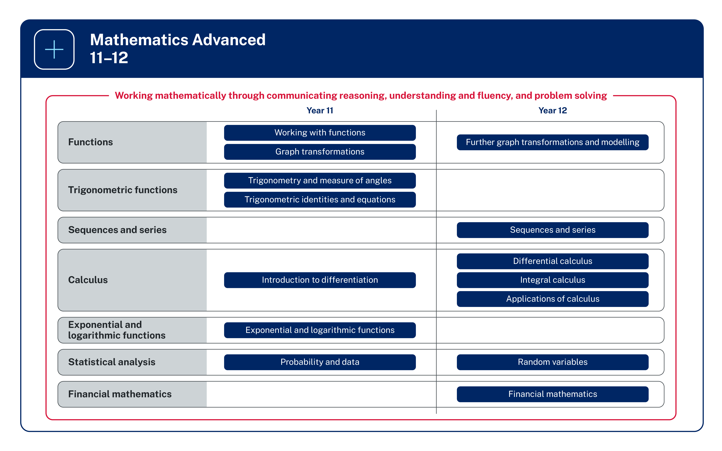
Figure 1: Organisation of Mathematics Advanced 11–12

Image long description: Seven rows represent the areas of study for Mathematics Advanced 11–12. Each row is divided in half, showing the focus areas for Year 11 and Year 12. The Functions area of study includes Year 11 focus areas Working with functions and Graph transformations and the Year 12 focus area Further graph transformations and modelling. The Trigonometric functions area of study includes the Year 11 focus areas Trigonometry and measure of angles and Trigonometric identities and equations. The Exponential and logarithmic function area of study includes the Year 11 focus area Exponential and logarithmic functions. The Sequences and series area of study includes the Year 12 focus area Sequences and series. The Calculus area of study includes the Year 11 focus area Introduction to differentiation, and the Year 12 focus areas Differential calculus, Integral calculus and Applications of calculus. Finally, the Statistical analysis area of study includes the Year 11 focus area Probability and data, and the Year 12 focus area Random variables. The Financial mathematics area of study includes the Year 12 focus area Financial mathematics. All content is surrounded by a box labelled with the phrase, ‘Working mathematically through communicating reasoning, understanding and fluency, and problem solving’.

Protocols for collaborating with Aboriginal and Torres Strait Islander Communities and engaging with Cultural works
NESA is committed to working in partnership with Aboriginal Communities and supporting teachers, schools and schooling sectors to improve educational outcomes for young people.
It is important to respect appropriate ways of interacting with Aboriginal Communities and Cultural material when teachers plan, program and implement learning experiences that focus on Aboriginal and Torres Strait Islander Priorities.
Indigenous Cultural and Intellectual Property (ICIP) protocols need to be followed. Aboriginal and Torres Strait Islander Peoples’ ICIP protocols include Cultural Knowledges, Cultural Expression and Cultural Property and documentation of Aboriginal and Torres Strait Islander Peoples’ Identities and lived experiences. It is important to recognise the diversity and complexity of different Cultural groups in NSW, as protocols may differ between local Aboriginal Communities.
Teachers should work in partnership with Elders, parents, Community members, Cultural Knowledge Holders, or a local, regional or state Aboriginal Education Consultative Group. It is important to respect Elders and the roles of men and women. Local Aboriginal Peoples should be invited to share their Cultural Knowledges with students and staff when engaging with Aboriginal histories and Cultural Practices.

Course description
Mathematics Advanced 11–12 focuses on mathematical ways of viewing the world to investigate concepts, such as order, relation, pattern, uncertainty and generality. The course provides students with the opportunity to explore mathematical problems through observation, reflection and reasoning.

What students learn
Through the study of Mathematics Advanced 11–12, students:
- develop knowledge, understanding and skills in Working mathematically and communicating concisely and precisely
- consider various applications of mathematics in a broad range of contemporary contexts through mathematical modelling
- gain an appropriate mathematical background for future pathways which involve mathematics and its applications at the tertiary level.

Course structure and requirements
Mathematics Advanced consists of the courses Mathematics Advanced Year 11 and Mathematics Advanced Year 12. Students must study both Mathematics Advanced Year 11 and Mathematics Extension 1 Year 11 courses before they can study Year 12 Mathematics Extension courses.
Alternatively, students can study both Mathematics Advanced Year 11 and Mathematics Advanced Year 12 before they begin either Mathematics Extension 1 Year 11 and Mathematics Extension 1 Year 12, or Mathematics Extension 1 Year 12 and Mathematics Extension 2 Year 12.
The course numbers and units for each year of study are set out below.
Course numbers:
- Mathematics Advanced (Year 11, 2 units): TBA
- Mathematics Advanced (Year 12, 2 units): TBA

Year 11 course structure
Area of study | Focus areas
Functions | Working with functions  Graph transformations
Trigonometric functions | Trigonometry and measure of angles  Trigonometric identities and equations
Calculus | Introduction to differentiation
Exponential and logarithmic functions | Exponential and logarithmic functions
Statistical analysis | Probability and data

Year 12 course structure
Area of study | Focus area
Functions | Further graph transformations and modelling
Calculus | Differential calculus  Integral calculus  Applications of calculus
Sequences and series | Sequences and series
Statistical analysis | Random variables
Financial mathematics | Financial mathematics

Further information for Mathematics Advanced Year 11
- Course number: TBA
- Course hours: 120
- Course units: 2
- Enrolment type: Elective
- Endorsement type: Board developed
- Study via self-tuition: Yes

Exclusions
- Mathematics Standard (Year 11, 2 units): TBA
- Mathematics Life Skills (Year 11, 2 units): TBA

Further information for Mathematics Advanced Year 12
- Course number: TBA
- Course hours: 120
- Course units: 2
- Enrolment type: Elective
- Endorsement type: Board developed
- Study via self-tuition: Yes

Exclusions
- Mathematics Standard 1 (Year 12, 2 units): TBA
- Mathematics Standard 2 (Year 12, 2 units): TBA
- Mathematics Life Skills (Year 12, 2 units): TBA

Rationale

Mathematics in the Stage 6 Curriculum
Mathematical ideas have evolved and continue to develop across cultures and have been practised in Australia by Aboriginal and Torres Strait Islander Peoples for thousands of years.
The utility of mathematics extends from counting and measuring to explaining real-world phenomena and its inherent beauty. It has evolved in sophisticated ways to become the language used to describe and understand much of the modern world.
The creative application of mathematical concepts is integral to scientific and technological advancement. The symbolic nature of mathematics provides a precise means of communication.
The Mathematics Stage 6 syllabuses are designed to offer students opportunities to think mathematically. Mathematical thinking is supported through questioning, communicating, reasoning, reflecting and the use of appropriate technology, and is encouraged through providing students with opportunities to generalise, challenge, find connections and to think critically and creatively. Using mathematical thinking, students apply their knowledge and skills to deepen their understanding of the world.

Mathematics Advanced
Mathematics Advanced, Mathematics Extension 1 and Mathematics Extension 2 form a continuum to provide students with opportunities to acquire knowledge, understanding and skills in mathematical concepts at progressively higher levels and with applications in an increasing number of contexts. Mathematics Advanced, Mathematics Extension 1 and Mathematics Extension 2 provide students with opportunities to learn about the interconnected nature of mathematics, its beauty and its functionality. The concepts and techniques of differential and integral calculus are the basis of the courses.
The Mathematics Advanced 11–12 Syllabus (2024) is designed to encourage students to appreciate mathematical ways of viewing the world to investigate concepts, such as order, relation, pattern, uncertainty and generality. The course provides students with the opportunity to explore mathematical problems through observation, reflection and reasoning.
The Mathematics Advanced 11–12 Syllabus (2024) enables students to use mathematical models and serves as a basis for further studies at the tertiary level in science and commerce that require mathematics and its applications.

Aim
The aim of Mathematics Advanced in Years 11 and 12 is to enable students to enhance their knowledge and understanding from Stage 5 of how to work mathematically, make mathematical connections, develop their understanding of the relationship between real-world problems and mathematical models, and extend their skills to apply the language of mathematics to communicate in a concise and systematic manner.

Table of outcomes
MAO-WM-01 Working mathematically
develops understanding and fluency in mathematics through exploring and connecting mathematical concepts, choosing and applying mathematical techniques to solve problems, and communicating their thinking and reasoning coherently and clearly
This outcome is aligned to all content in each Stage.
Year 11 | Year 12
MAV-11-01  applies algebraic techniques and the laws of indices and surds to manipulate expressions and solve problems | MAV-12-01  uses algebraic and graphical techniques to analyse trigonometric functions
MAV-11-02  uses functions and relations to model, analyse and solve problems | MAV-12-02  models, analyses and solves practical problems involving functions and their transformations
MAV-11-03  analyses and solves algebraic and graphical problems involving transformations of functions and relations | MAV-12-03  uses arithmetic and geometric sequences and series to model and solve problems
MAV-11-04  applies trigonometry to solve problems involving geometric shapes | MAV-12-04  selects and applies differentiation methods to solve problems
MAV-11-05  uses periodic functions to solve trigonometric equations and prove trigonometric identities | MAV-12-05  solves problems involving indefinite and definite integrals
MAV-11-06  interprets the meaning of the derivative and determines the derivative of functions to solve problems | MAV-12-06  applies calculus to graph functions and model and solve problems involving optimisation, rates of change and motion in a line
MAV-11-07  applies exponential and logarithmic laws to simplify expressions, solve equations and prove results | MAV-12-07  solves problems involving discrete probability distributions, continuous random variables and the normal distribution
MAV-11-08  analyses graphs of exponential and logarithmic functions | MAV-12-08  models and solves problems to make informed decisions about financial situations
MAV-11-09
solves problems involving probability in a variety of contexts
MAV-11-10
displays and analyses datasets using summary statistics and graphical representations

Outcomes and content for Year 11

Working with functions

Outcomes
A student:
- develops understanding and fluency in mathematics through exploring and connecting mathematical concepts, choosing and applying mathematical techniques to solve problems, and communicating their thinking and reasoning coherently and clearly MAO-WM-01
- applies algebraic techniques and the laws of indices and surds to manipulate expressions and solve problems MAV-11-01
- uses functions and relations to model, analyse and solve problems MAV-11-02

Content

Algebraic techniques
- Use index laws to simplify expressions and solve problems involving positive, negative, zero or fractional indices
- Expand, factorise and simplify algebraic expressions
- Simplify expressions involving algebraic fractions
Example(s):
Simplify $$\frac{a^{3}b-ab^{3}}{a^{2}+2ab+b^{2}}$$, $$\frac{m^{3}+m^{2}}{x^{2}-x}÷\frac{m+1}{x-x^{3}}$$ and $$\frac{x^{2}}{x^{2}+3x+2}-\frac{x}{x+1}$$.

- Expand and simplify expressions involving surds
- Identify the conjugate of $$\sqrt{a}±\sqrt{b}$$, and rationalise the denominators of expressions of the form $$\frac{a}{\sqrt{b}±\sqrt{c}}$$ and $$\frac{\sqrt{a}±\sqrt{d}}{\sqrt{b}±\sqrt{c}}$$, where $$a$$, $$b$$, $$c$$ and $$d$$ are positive rational numbers
- Solve quadratic equations $$ax^{2}+bx+c=0$$ by factorisation, completing the square and using the quadratic formula $$x=\frac{-b±\sqrt{b^{2}-4ac}}{2a}$$ where $$a$$, $$b$$ and $$c$$ are real numbers and $$a≠0$$
- Define the discriminant as $$Δ=b^{2}-4ac$$ and use it to solve problems involving the number of real roots of a quadratic equation and determine the conditions for roots to be equal, distinct, real or rational
Example(s):
Find $$k$$ if the equation $$\left(2k+3\right)x^{2}-4kx+4=0$$ has equal roots.

Introduction to functions and relations
- Describe a relation between two sets as an association between the elements of one set and the elements of the other set
Example(s):
A relation between the elements of a set $$A$$ and a set $$B$$ can be described as the set of ordered pairs $$\left(x,y\right)$$ where $$x$$ is a member of $$A$$ and $$y$$ is a member of $$B$$ related to $$x$$. Consider the relation between the set of ‘names of students in the class’ and ‘month of birth’.

- Define a real function $$f$$ of a real variable $$x$$ as a relation where each element $$x$$ of a given set is associated with exactly one element $$y$$ of the second set
Example(s):
$$f$$ is a function in which every element in $$X$$ is associated with exactly one element of $$Y$$. $$g$$ is not a function but a relation, as element 1 in set $$X$$ is assigned to the two elements 5 and 6 in set $$Y$$.
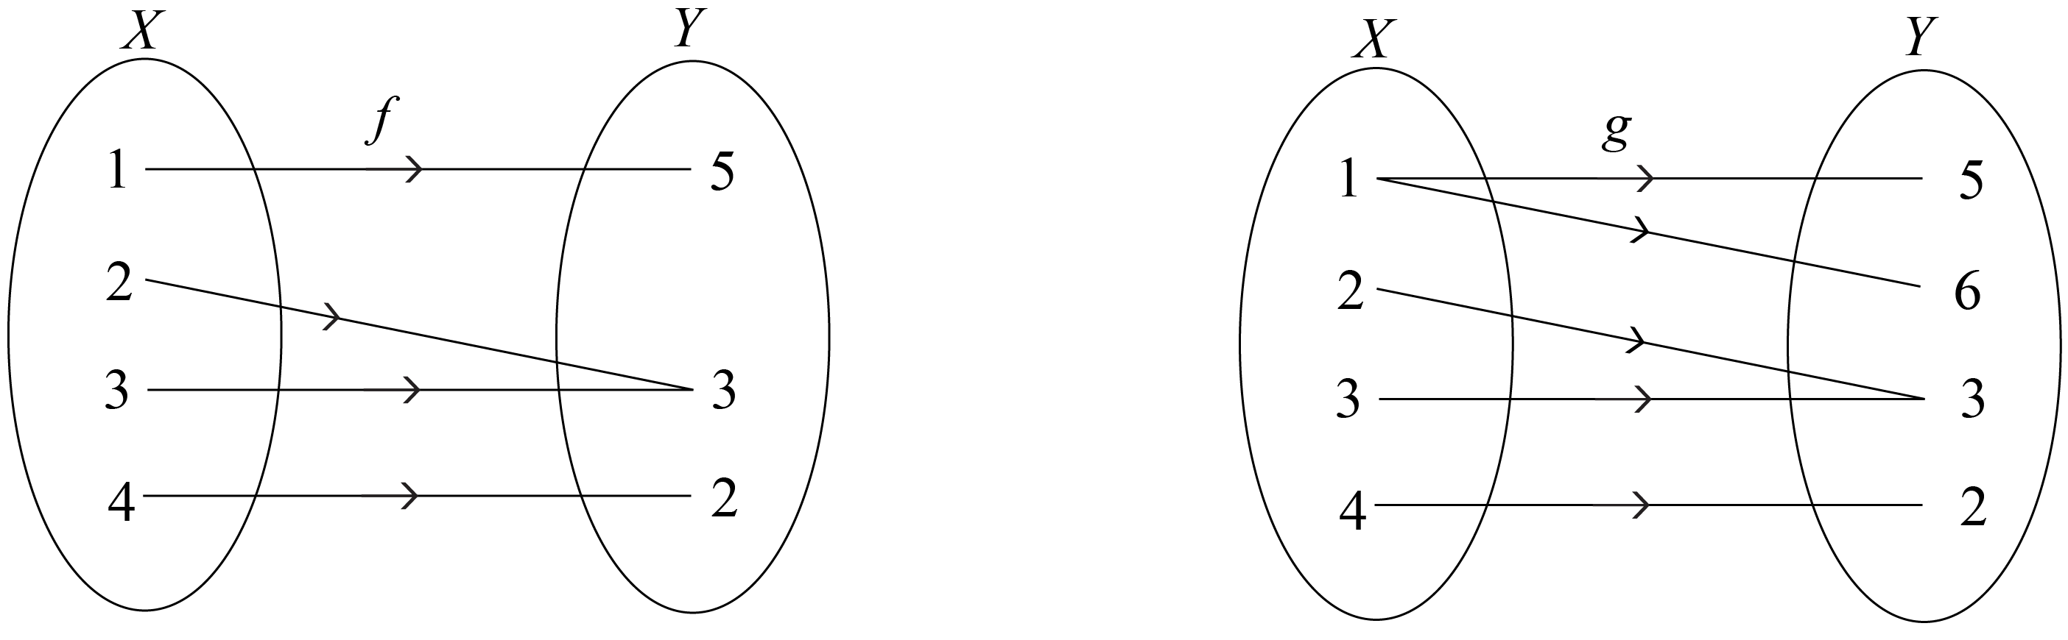
Image long description: The first image shows a function $$f$$ associating the elements 1, 2, 3 and 4 in a set $$X$$ to the elements 5, 3 and 2 in a set $$Y$$, so that 1 is mapped to 5, 2 and 3 are mapped to 3, and 4 is mapped to 2. The second image shows relation $$g$$ associating the elements 1, 2, 3, and 4 in a set $$X$$ with the elements 5, 6, 3, and 2 in a set $$Y$$, so that 1 is mapped to 5 and 6, 2 and 3 are mapped to 3, and 4 is mapped to 2.

- Recognise that a relation is a rule which can be represented by an algebraic formula, a table of values, a set of ordered pairs $$\left(x,y\right)$$ or a graph
Example(s):
$$G=\{\left(1,5\right),\left(4,2\right),\left(2,3\right),\left(3,3\right),\left(1,6\right)\}$$ is a relation.

- Use the notation $$f\left(x\right)$$ to identify the unique value of $$y$$ associated with $$x$$ when working with functions, and refer to it as the value of $$f$$ at $$x$$
- Refer to $$x$$ in a function $$y=f(x)$$ as the independent variable of the function, and refer to $$y$$ as the dependent variable
- Substitute numeric and algebraic expressions into the formulas of functions
- Apply the vertical line test on the graph of a relation to determine whether it represents a function
- Define the domain of a function $$f$$ as the set of real numbers on which $$f$$ is defined
- Define the range of a function $$f$$ as the set of values of $$f(x)$$ obtained as $$x$$ varies over the domain of $$f$$
- Refer to a value in the domain of a function at which the function is 0 as a zero of the function
- Recognise that the $$x$$-intercepts of the graph of $$y=f\left(x\right)$$ are its zeroes, the solutions of $$f\left(x\right)=0$$, and that the $$y$$-intercept is $$f\left(0\right)$$

Linear functions
- Determine the equations of straight lines in gradient–intercept form $$y=mx+c$$ with gradient $$m$$ and $$y$$-intercept $$c$$
- Determine the equations of straight lines in general form $$ax+by+c=0$$, where $$a$$, $$b$$ and $$c$$ are constants
- Determine the equation of a straight line passing through a point $$\left(x_{1},y_{1}\right)$$ with gradient $$m$$ using the point–gradient formula $$y-y_{1}=m\left(x-x_{1}\right)$$
- Determine the equation of a straight line passing through two points $$\left(x_{1},y_{1}\right)$$ and $$\left(x_{2},y_{2}\right)$$ by calculating its gradient $$m$$ using the formula $$m=\frac{y_{2 }- y_{1}}{x_{2 }- x_{1}}$$
Example(s):
Find the equation of the line that has a gradient of $$3$$ and passes through the point $$\left(2,-5\right)$$ and hence determine whether the point $$(5,8)$$ lies on that line.

- Determine the $$x$$-intercept and $$y$$-intercept of a straight line given its equation
- Choose and apply appropriate techniques to graph a straight line given its equation
- Find the equation of a line that is parallel or perpendicular to a given line
- Solve linear inequalities and graph the solution on a number line

Quadratic and cubic functions
- Identify the $$x$$-intercepts of a parabola whose quadratic function is expressed in factored form
- Use the discriminant to determine the number of $$x$$-intercepts on a parabola and justify its position in relation to the $$x$$-axis
Example(s):
Show that the discriminant of $$y={-x}^{2}+2x-2$$ is negative and justify why its graph lies entirely below the $$x$$-axis.

- Show by completing the square on the general quadratic $$y=ax^{2}+bx+c$$ that the axis of symmetry is $$x=-\frac{b}{2a}$$ where $$a$$, $$b$$ and $$c$$ are constants
- Identify the axis of symmetry and vertex of a parabola by completing the square on its quadratic function
- Choose and apply appropriate techniques to graph a parabola of the form $$y={ax}^{2}+bx+c$$ by identifying its $$x$$-intercepts if they exist, its $$y$$-intercept, its axis of symmetry using $$x=-\frac{b}{2a}$$ and its vertex
Example(s):
Express $$y=x^{2}+2x+3$$ in the form $$y={\left(x-a\right)}^{2}+c$$ and determine the coordinates of the vertex. Graph the parabola showing its $$y$$-intercept.

- Find the equation of a parabola given sufficient graphical features
- Use the fact that two quadratic functions are equal for all values of $$x$$ if and only if the corresponding coefficients are equal to solve related problems
Example(s):
Find the values of $$a$$, $$b$$ and $$c$$ if the quadratic functions $$f\left(x\right)=x^{2}-x$$ and $$f\left(x\right)=a{\left(x+3\right)}^{2}+bx+c-1$$ have the same graph.

- Recognise that solving $$f\left(x\right)=k$$ for some constant $$k$$ corresponds to finding the $$x$$-coordinate(s) of the intersection of the graphs $$y=f\left(x\right)$$ and $$y=k$$
- Solve problems by finding the solution to simultaneous equations involving a linear and a quadratic function, or two quadratic functions, both algebraically and graphically
- Solve quadratic inequalities
- Recognise and graph cubic functions of the form $$f(x)=kx^{3}$$ and $$f\left(x\right)=k\left(x-a\right)\left(x-b\right)\left(x-c\right)$$, where $$a$$, $$b$$, $$c$$ and $$k$$ are constants and $$k≠0$$

Reciprocal functions
- Graph functions of the form $$f(x)=\frac{k}{x}$$, where $$k$$ is a constant and $$k≠0$$, and identify their hyperbolic shape and their asymptotes
- Describe the behaviour of $$f\left(x\right)=\frac{k}{x}$$ as $$x→∞$$ and $$x→-∞$$
Example(s):
For $$f\left(x\right)=\frac{-2}{x}$$ as $$x→∞, f(x)→0$$ and as $$x→-∞, f(x)→0$$.

Constructing and using functions
- Construct and use linear functions to model and solve problems in real-world situations, identifying the independent and dependent variables and any restrictions on these variables, and justify conclusions in the context of the problem
- Use linear inequalities to model and solve problems in real-world situations, and justify conclusions in the context of the problem
- Solve practical problems involving a pair of simultaneous linear equations both algebraically and graphically, with and without graphing applications, and justify conclusions in the context of the problem
- Construct and use simultaneous equations to model and solve a problem where cost and revenue are represented by linear equations, identify and analyse the break-even point, and justify conclusions in the context of the problem
- Model and solve practical problems involving quadratic functions and justify conclusions in the context of the problem

Direct and inverse variation
- Develop models of the form $$y=kx^{n}$$, where $$k$$ is a non-zero constant, from descriptions of situations in which one quantity varies directly with another
- Develop the model $$y=\frac{k}{x^{n}}$$, where $$k$$ is a non-zero constant, from descriptions of situations in which one quantity varies inversely with another
- Evaluate $$k$$ in the equations $$y=kx^{n}$$ and $$y=\frac{k}{x^{n}}$$, given one pair of values for the variables, and use the resulting formula to find other values of the variables
- Analyse and solve problems involving direct and inverse variation

Circles and semicircles
- Derive the equation of a circle of radius $$r$$ with centre at the origin by considering Pythagoras’ theorem
- Graph circles of the form $$x^{2}+y^{2}=r^{2}$$ from their equations
- Determine the equation of a circle of the form $$x^{2}+y^{2}=r^{2}$$ given its graph
- Identify and graph the semicircles $$y=\sqrt{r^{2}-x^{2}}$$, $$y=-\sqrt{r^{2}-x^{2}}$$, $$x=\sqrt{r^{2}-y^{2}}$$ and $$x=-\sqrt{r^{2}-y^{2}}$$

Properties of functions, relations and graphs
- Extend the definitions of domain and range to relations
- Recognise domains and ranges of functions and relations given in interval notation, as inequalities and as worded descriptions
- Determine and describe the domain and range of functions and relations, using interval notation, inequalities or worded descriptions
Example(s):
The domain and range of $$y=\sqrt{x-4}$$ can be expressed in interval notation as $$\left[4,\left.∞\right)\right.$$ and $$[0,∞)$$ respectively. The range of $$y=2^{x}$$ is the set of $$y$$ satisfying $$y>0$$. The domain of $$2x-3y+2=0$$ is all real $$x$$.

- Define a function to be even if its graph is unchanged under reflection in the $$y$$-axis, and odd if its graph is unchanged under rotation of $$180°$$ about the origin
- Develop and use the tests that a function $$f(x)$$ is odd if $$f\left(-x\right)=-f(x)$$ and a function $$f(x)$$ is even if $$f\left(-x\right)=f(x)$$
- Solve problems involving even and odd functions
- Use the composite function $$f\left(g\left(x\right)\right)$$, where the output of $$g\left(x\right)$$ becomes the input of $$f\left(x\right)$$
- Determine the equations of composite functions
Example(s):
Given the functions $$f(x)=x-2$$ and $$g\left(x\right)=x^{2}$$, determine the equation of $$f(g\left(x\right))$$ and evaluate $$g\left(f\left(2\right)\right)$$.

Piecewise-defined functions
- Interpret piecewise-defined functions, where the function is defined differently in different parts of the domain
- Graph piecewise-defined functions involving functions covered in the scope of the Mathematics Advanced course, test if they are even or odd, and determine the domain and range
Example(s):
Graph the function $$f\left(x\right)=\left\{\begin{matrix}x^{2}, \\ x-1, \\ {-x}^{3},\end{matrix}\right. \begin{matrix}\text{for} x≤-1, \\ \text{for}-1<x≤1, \\ \text{for} x>1.\end{matrix}$$. Mark endpoints of the graph with a closed circle or an open circle depending on whether the endpoint is included or not included.

- Define informally that a function is continuous at a point if the curve can be drawn through the point without lifting the pen off the paper
- Identify points where piecewise-defined functions and other functions are not continuous
Example(s):
Identify any places where the graphs of $$f\left(x\right)=\frac{x^{2}-1}{x-1}$$ and $$f\left(x\right)=\frac{|x|}{x}$$ are not continuous and graph the functions.

- Define a discontinuity of a function informally as a point where the function is not continuous

Absolute value functions
- Define the absolute value $$\left|x\right|$$ of a number $$x$$, also known as the magnitude of $$x$$, to be the distance from the origin to $$x$$ on the number line
- Establish and use the piecewise definition $$\left|x\right|=\left\{\begin{matrix}x, \text{for} x≥0, \\ -x, \text{for} x<0\end{matrix}\right.$$
- Show using numerical substitutions that $$\sqrt{x^{2}}=\left|x\right|$$ and use the result
- Graph the function $$y=\left|x\right|$$, describe its symmetry, and identify its domain and range
- Graph $$y=\left|ax+b\right|$$ with and without graphing applications, and identify its symmetry, domain and range
- Solve absolute value equations of the form $$\left|ax+b\right|=k$$ algebraically and graphically
Example(s):
Graph $$y=4$$ and $$y=\left|2x-2\right|$$ on the same number plane and hence solve $$\left|2x-2\right|=4$$.

Trigonometry and measure of angles

Outcomes
A student:
- develops understanding and fluency in mathematics through exploring and connecting mathematical concepts, choosing and applying mathematical techniques to solve problems, and communicating their thinking and reasoning coherently and clearly MAO-WM-01
- applies trigonometry to solve problems involving geometric shapes MAV-11-04

Content

Trigonometry with acute angles
- Use Pythagoras’ theorem to find the exact sine, cosine and tangent ratios for angles of $$30°$$, $$45°$$ and $$60°$$
- Apply trigonometry to solve problems involving right-angled triangles in two dimensions, true and compass bearings, and angles of elevation and depression

Trigonometry with angles of any magnitude
- Represent angles of any magnitude using rays from the origin in the Cartesian plane and describe how one ray represents infinitely many angles
- Develop the definitions $$\cos{θ}=\frac{x}{r}$$, $$\sin{θ}=\frac{y}{r}$$ and $$\tan{θ}=\frac{y}{x}$$, where $$(x,y)$$ is a point on the circle of radius $$r$$, centred at the origin, and $$θ$$ is the angle between the positive $$x$$-axis and the radius drawn to this point
- Use the definitions $$\cos{θ}=\frac{x}{r}$$, $$\sin{θ}=\frac{y}{r}$$ and $$\tan{θ}=\frac{y}{x}$$ to evaluate $$\sin{θ}$$, $$\cos{θ}$$ and $$\tan{θ}$$ where $$θ$$ is a multiple of $$90°$$, and identify the values of $$θ$$ for which these ratios are undefined
- Extend and apply the definitions $$\cos{θ}=\frac{x}{r}$$, $$\sin{θ}=\frac{y}{r}$$ and $$\tan{θ}=\frac{y}{x}$$ for angles of any magnitude
- Identify the related angle of an angle of any magnitude, excluding multiples of $$90°$$, as the acute angle between the ray and the $$x$$-axis and obtain the values of the trigonometric functions of an angle of any magnitude from the trigonometric functions of the related angle
- Develop and use the trigonometric ratios for angles that can be written in the form $$θ=180°±A$$, and $$θ=360°-A$$, where $$0°<A<90°$$
Example(s):
Find the exact value of $$\sin{(-120°)}$$ and $$\tan{585°}$$.

- Establish and use the results $$\cos{(-θ)}=\cos{θ}$$, $$\sin{(-θ)}=-\sin{θ}$$ and $$\tan{(-θ)}=-\tan{θ}$$
- Examine the proof of the sine rule $$\frac{a}{\sin{A}}=\frac{b}{\sin{B} }=\frac{c}{\sin{C}}$$ , cosine rule $$c^{2}=a^{2}+b^{2}-2ab\cos{C}$$ and the area of a triangle formula $$A=\frac{1}{2}ab\sin{C}$$ for a given triangle $$ABC$$
- Use graphing applications or geometric construction to examine the ambiguous case of the sine rule, in which there are two possible solutions for an angle, and the condition for it to arise
Example(s):
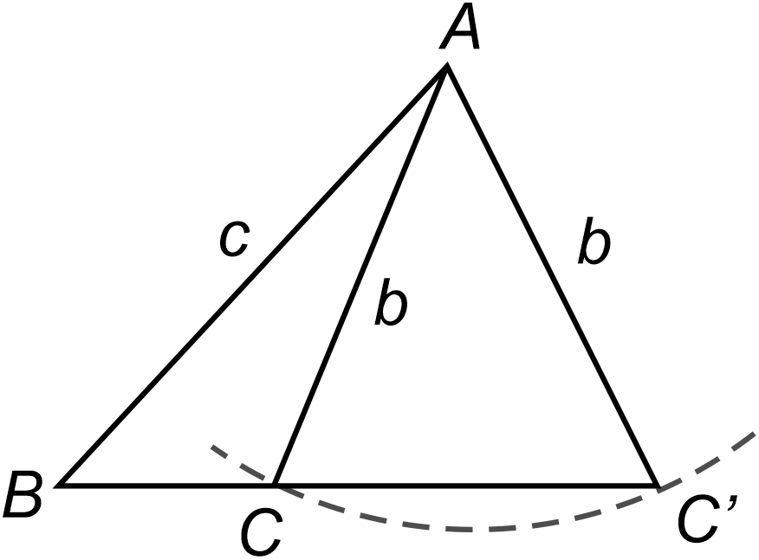
Image long description: A triangle $$ABC'$$ with sides $$b$$ and $$c$$ contains a smaller triangle with 2 sides $$b$$. The internal side $$b$$ intersects line $$BC'$$ at point $$C$$. An arc connects points $$C$$ and $$C'$$, demonstrating that the movement of point $$C$$ can adjust the angle $$ACB$$ so it is either obtuse or acute.

- Apply the sine rule, cosine rule and formula for the area of a triangle to solve problems where angles are measured in degrees, or degrees and minutes

Radians
- Recognise that both ratios $$\frac{\text{arc length}}{\text{circumference}}$$ and $$\frac{\text{area of sector}}{\text{area of circle}}$$ are equal to $$\frac{θ}{\text{one revolution}}$$ where $$θ$$ is the angle at the centre of a circle subtended by the arc
- Define the angle size of $$θ$$ in radian measure as the ratio $$\frac{\text{arc length}}{\text{radius of a circle}}$$
- Explain why $$360°=2π$$ radians and $$\text{1 radian}=\frac{180}{π}\text{ degrees}$$
- Convert between degrees and radians and find the exact sine, cosine and tangent ratios for integer multiples of $$\frac{π}{6}$$ and $$\frac{π}{4}$$
- Graph $$y=sin x$$, $$y=cos x$$ and $$y=tan x$$ over domains given in degrees or radians, showing intercepts with the $$x$$-axis and $$y$$-axis and any asymptotes, determine their domains and ranges, and period and amplitude where appropriate, and whether each is even or odd or neither
- Establish and use the formula $$l=rθ$$ for the length $$l$$ of arc subtending an angle $$θ$$ in radians at the centre of a circle of radius $$r$$
- Prove and use the formula $$A=\frac{1}{2}r^{2}θ$$ for the area of a sector with angle $$θ$$ in radians at the centre of a circle of radius $$r$$
- Solve problems involving arc lengths and areas of major and minor sectors and segments

Trigonometric identities and equations

Outcomes
A student:
- develops understanding and fluency in mathematics through exploring and connecting mathematical concepts, choosing and applying mathematical techniques to solve problems, and communicating their thinking and reasoning coherently and clearly MAO-WM-01
- uses periodic functions to solve trigonometric equations and prove trigonometric identities MAV-11-05

Content
- Define the trigonometric functions $$\sec{θ}$$, $$cosecθ$$ and $$\cot{θ}$$ for acute angles $$θ$$ using ratios of sides in a right-angled triangle
- Find the exact secant, cosecant and cotangent ratios for angles of $$30°$$, $$45°$$ and $$60°$$
- Justify the values of $$\sec{θ}$$, $$cosecθ$$ and $$\cot{θ}$$ at $$0°$$ and $$90°$$ by examining the ratios of sides in a right-angled triangle as $$θ$$ tends to $$0°$$ and $$90°$$
- Develop the definitions $$\sec{θ=\frac{r}{x}}$$, $$cosecθ=\frac{r}{y}$$ and $$\cot{θ}=\frac{x}{y}$$ using a circle of radius $$r$$ centred at the origin
- Establish the reciprocal ratios $$\sec{A}=\frac{1}{\cos{A}}$$, $$\operatorname{cosec}{A}=\frac{1}{\sin{A}}$$, and $$\cot{A}=\frac{1}{\tan{A}}$$, identifying the angles to be excluded in each identity
- Determine the exact value of the secant, cosecant and cotangent ratios for angles that are integer multiples of $$\frac{π}{6}$$ and $$\frac{π}{4}$$, if they exist
- Establish the identities $$\tan{θ}=\frac{\sin{θ}}{\cos{θ}}$$ and $$\cot{θ}=\frac{\cos{θ}}{\sin{θ}}$$, identifying the angles to be excluded in each identity
- Prove the complementary angle identities $$\sin{(90°-}θ)=\cos{θ}$$, $$\cos{(90°-θ)=sin}{θ}$$, $$\tan{(90°-θ)=cot}{θ}$$, $$\cot{(90°-θ)=tan}{θ}$$, $$\sec{(90°-θ)=cosec}{θ}$$ and $$\operatorname{cosec}{(90°-θ)=sec}{θ}$$ identifying the angles to be excluded in each identity
- Evaluate trigonometric expressions using angles of any magnitude and complementary angle identities
Example(s):
Given $$cot α=-\frac{15}{8}$$, and that $$\frac{π}{2}<α<π$$, find the values of $$cosec α$$ and $$\cos{α}$$.

- Solve equations involving trigonometric ratios of angles, specified in degrees or radians, on a restricted domain
Example(s):
Solve $$\sqrt{3}\sin{x}=\cos{x}$$ for $$0°≤x≤360°$$ and $$2\cos{2x=0}$$ for $$-π≤x≤π$$.

- Prove the Pythagorean identity $$\cos^{2}{x}+\sin^{2}{x}=1$$, and the identities $$1+\tan^{2}{x}=\sec^{2}{x}$$ and $$1+\cot^{2}{x}={cosec}^{2}{x}$$
- Apply trigonometric identities to solve problems, simplify expressions and prove further trigonometric identities using substitution and/or reduction to $$\sin{x}$$ and $$\cos{x}$$
Example(s):
Prove that $$\sec^{2}{x+sec}{x}\tan{x=\frac{1+\sin{x}}{\cos^{2}{x}}}$$ and hence prove that $$\sec^{2}{x}+\sec{x}\tan{x}=\frac{1}{1-\sin{x}}$$.

- Solve problems involving trigonometric equations, including those that reduce to quadratic equations, on a restricted domain
Example(s):
Express $$5\cot^{2}{x}-2\operatorname{cosec}{x}+2$$ in terms of $$\operatorname{cosec}{x}$$ and hence solve the equation $$5\cot^{2}{x}-2\operatorname{cosec}{x}+2=0$$ for $$0≤x<2π$$.

Introduction to differentiation

Outcomes
A student:
- develops understanding and fluency in mathematics through exploring and connecting mathematical concepts, choosing and applying mathematical techniques to solve problems, and communicating their thinking and reasoning coherently and clearly MAO-WM-01
- interprets the meaning of the derivative and determines the derivative of functions to solve problems MAV-11-06

Content

Estimating change
- Define the average rate of change of $$y$$ with respect to $$x$$ for a function $$y=f\left(x\right)$$ over the domain $$[a,b]$$ as $$\frac{Δy}{Δx}=\frac{\text{change in }y}{\text{change in }x}$$, that is $$\frac{Δy}{Δx}=\frac{f\left(b\right)-f(a)}{b-a}$$, and recognise $$\frac{f\left(b\right)-f(a)}{b-a}$$ as the gradient of the secant through $$\left(a,f\left(a\right)\right)$$ and $$\left(b,f\left(b\right)\right)$$ on the graph of $$y=f(x)$$
- Recognise speed as a rate of change of distance with respect to time
- Use the definition for average rate of change to determine the average speed of an object from a given distance–time graph
- Describe the difference between the average speed of an object and its instantaneous speed
- Determine that the instantaneous speed of an object at time $$t$$ can be approximated by the average speed between its position at time $$t$$ and its position some time later, and explain how this approximation can be improved
- Relate the instantaneous speed of an object to the gradient of the tangent at that point on its distance–time graph
- Estimate the instantaneous speed of an object from its distance–time graph
- Recognise when modelling with a linear function that its gradient is the rate of change and determine the rate of change for linear functions in practical situations
- Recognise when modelling with a non-linear function that the rate of change is not constant and is represented by the gradient of the tangent to the curve at each point on the curve
- Estimate the instantaneous rate of change of a non-linear function at a given point from a given graph of a practical situation
Example(s):
The graph shows the displacement of a particle that is moving in a horizontal line. Estimate the velocity of the particle as it passes through the origin.
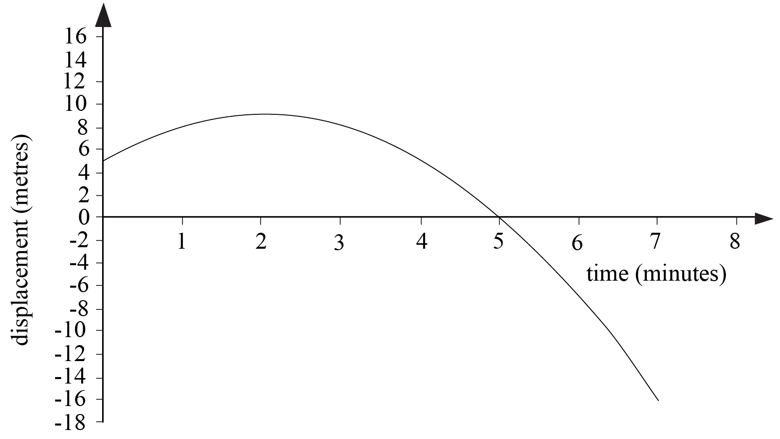
Image long description: A graph of a distance–time function with displacement in metres on the y-axis and time in minutes on the x-axis. It depicts a distance-time function that is in the shape of a concave down parabola with a distance intercept of 5 metres and time intercept of 5 minutes. The vertex of the parabola is at the point $$(2, 9)$$.

The derivative
- Examine the gradient of a curve at a point on the curve using graphing applications
Example(s):
Use a graphing application to magnify the graph of $$y=x^{2}$$ at $$x=1$$. Discuss the ‘straightness’ of the graph when magnified.

- Approximate the gradient of a curve $$f(x)=x^{n}$$ at a point $$P\left(c,f\left(c\right)\right)$$ by considering the gradient of the secant through $$P$$ and $$Q\left(c+h,f\left(c+h\right)\right)$$ as the magnitude of $$h$$ approaches zero, using graphing applications or a spreadsheet
Example(s):
Use a spreadsheet or graphing application to examine the gradient of $$f(x)=x^{n}$$, $$n=2$$ and $$3$$ at $$P(c,f\left(c\right))$$ for various values of $$c$$ by considering the value of $$\frac{f\left(c+h\right)-f(c)}{h}$$ as $$h$$ steadily decreases.

- Infer that $$nx^{n-1}$$ is the gradient of $$f\left(x\right)=x^{n}$$ and verify the result using graphing applications
Example(s):
Use a graphing application to find an approximation for the gradient of $$f(x)=x^{n}$$ by considering the graph of $$y=\frac{f\left(x+0.001\right)-f(x)}{h}$$ for $$n=2$$ and $$3$$. Summarise the results for the gradients of $$y=1$$, $$y=x$$, $$y=x^{2}$$ and $$y=x^{3}$$ and generalise the result for $$y=x^{n}$$.
Use a graphing application to verify the result for positive, negative and fractional values of $$n$$.

- Define $$f'(x)$$, for any function $$f(x)$$ and any value $$x$$, to be the gradient of the tangent to the curve $$y=f(x)$$ at the point $$P\left(x,f\left(x\right)\right)$$ if the tangent exists and is not vertical
- Refer to $$f'(x)$$ as the derivative of $$f(x)$$ or the gradient, or derived, function of $$f(x)$$
- Define differentiation as the process of finding the derivative of a function
- Find derivatives of constant and linear functions
- Define the derivative of the function $$f\left(x\right)$$ from first principles, as the limiting value of the gradient of the secant $$\frac{f\left(x+h\right)-f\left(x\right)}{h}$$ as $$h$$ approaches zero, when this limiting value exists, and use the notation $$f'\left(x\right)=\lim_{h→0}\frac{f\left(x+h\right)-f\left(x\right)}{h}$$
- Use first principles to find the derivative of quadratic functions
Example(s):
Use differentiation by first principles to verify that if $$y=3x^{2}-x$$, then $$y'=6x-1$$.

Calculations with the derivative
- Use the notation $$\frac{dy}{dx}$$ and $$y'$$ for the derivative of $$y$$ when $$y$$ is a function of $$x$$
- Use the notation $$\frac{d}{dx}\left(f\left(x\right)\right)$$ and $$f'(x)$$ for the derivative of a function $$f\left(x\right)$$
- Use the formula $$\frac{d}{dx}(x^{n})=nx^{n-1}$$ for all real values of $$n$$
Example(s):
Find the derivative of $$f\left(x\right)=x^{7}$$, $$f\left(t\right)=\sqrt{t}$$ and $$g\left(x\right)=\frac{1}{x^{3}}$$.

- Apply the fact that the derivative of a sum is the sum of the derivatives: $$\frac{d}{dx}\left(f\left(x\right)+g\left(x\right)\right)=f'\left(x\right)+g'(x)$$, and the derivative of a multiple of a function is the multiple of its derivative: $$\frac{d}{dx}(k⋅f\left(x\right))=k⋅f'(x)$$
- Use the rules for differentiation to find equations of tangents and normals to a curve at points on the curve
- Find points on a curve where the tangent or normal has a given gradient
- Examine and use the relationship between the angle of inclination of a line or tangent to a curve, $$θ,$$ with the positive $$x$$-axis, and the gradient, $$m$$, of that line or tangent, and establish that $$\tan{θ}=m$$
- Apply the product rule: if $$y=uv$$, where $$u$$ and $$v$$ are both differentiable functions of $$x$$, then $$\frac{dy}{dx}=u\frac{dv}{dx}+v\frac{du}{dx}$$ or if $$h(x)=f(x)g(x)$$ for differentiable functions $$f(x)$$ and $$g(x)$$ then $$h'\left(x\right)=f\left(x\right)g'\left(x\right)+f'\left(x\right)g(x)$$
- Apply the quotient rule: if $$y=\frac{u}{v}$$, where $$u$$ and $$v$$ are both functions of $$x,$$ then $$\frac{dy}{dx}=\frac{v\frac{du}{dx}-u\frac{dv}{dx}}{v^{2}}$$ or if $$h\left(x\right)=\frac{f\left(x\right)}{g\left(x\right)}$$ then $$h'\left(x\right)=\frac{g\left(x\right)f^{'}\left(x\right)-f\left(x\right)g^{'}\left(x\right)}{[{g\left(x\right)]}^{2}}$$
- Apply the chain rule: if$$y$$ is a differentiable function of $$u$$, and $$u$$ is a differentiable function of $$x$$, then $$\frac{dy}{dx} = \frac{dy}{du}×\frac{du}{dx}$$ or if $$h\left(x\right)=f\left(g\left(x\right)\right)$$ for differentiable functions $$f(x)$$ and $$g(x)$$ then $$h'\left(x\right)=f'\left(g\left(x\right)\right)g'\left(x\right)$$
- Identify and apply the product, quotient or chain rule, or a combination of the rules, as appropriate to differentiate a given function

Graphical applications of the derivative
- Interpret $$f\left(x\right)$$ as increasing at $$x=c$$ when $$f'\left(c\right)>0$$ and decreasing at $$x=c$$ when $$f'\left(c\right)<0$$
- Describe the behaviour of a function at a point as stationary when the tangent at the point is parallel to the $$x$$-axis, and recognise that $$f\left(x\right)$$ is stationary at $$x=c$$ when $$f'\left(c\right)=0$$
- Graph $$y=f^{'}(x)$$ for a given graph of a function $$y=f(x)$$
- Numerically estimate the value of the derivative at a point on the graph of a power of $$x$$, with and without the use of digital tools
- Identify stationary points on the graph of a cubic function, and the values of $$x$$ for which the function is increasing and/or decreasing, by first calculating the derivative, and justify conclusions

The derivative as a rate of change
- Interpret $$f'(c)$$ as the instantaneous rate of change of the function $$f(x)$$ at $$x=c$$
- Define and distinguish between displacement and distance and between velocity and speed
- Use graphs of functions and their derivatives, without the use of algebraic techniques, to describe and interpret physical phenomena
- Use the notation $$\frac{dx}{dt}$$ or $$\dot{x}$$ to represent the velocity of a particle with displacement $$x$$ from a point as a function of time $$t$$
- Solve problems by determining the velocity of a particle moving in a straight line, given its displacement from a point as a function of time

Exponential and logarithmic functions

Outcomes
A student:
- develops understanding and fluency in mathematics through exploring and connecting mathematical concepts, choosing and applying mathematical techniques to solve problems, and communicating their thinking and reasoning coherently and clearly MAO-WM-01
- applies exponential and logarithmic laws to simplify expressions, solve equations and prove results MAV-11-07
- analyses graphs of exponential and logarithmic functions MAV-11-08

Content

Exponential functions
- Graph the exponential functions $$y=k\left(a^{x}\right)$$ and $$y=k\left(a^{-x}\right)$$ for constants $$a$$ and $$k$$ where $$a>0$$, $$a≠1$$ and $$k≠0$$, and identify its asymptote, $$y$$-intercept, domain and range
- Describe the behaviour of $$y=k\left(a^{x}\right)$$ and $$y=k\left(a^{-x}\right)$$ as $$x→∞$$ and $$x→-∞$$
Example(s):
For $$y=2^{x}$$, as $$x→-∞$$, $$y→0$$ and as $$x→∞$$, $$y→∞$$.

- Examine the gradient of the tangent to the curve $$y=a^{x}$$ at its $$y$$-intercept for varying values of $$a$$, and verify using graphing applications that there is a unique number $$e≈2.71828182845$$..., such that the gradient of the tangent to $$y=e^{x}$$ at $$x=0$$ is 1, and call this number $$e$$ Euler’s number
- Examine the gradient function of $$y=a^{x}$$ with graphing applications and identify that the gradient function is $$\frac{d}{dx}\left(a^{x}\right)=ka^{x}$$, for some constant $$k$$ depending only on $$a$$
- Conclude that Euler’s number, $$e$$, is a unique number such that $$\frac{d}{dx}\left(e^{x}\right)=e^{x}$$, that is, $$e^{x}$$ is its own derivative

Logarithmic functions
- Define the logarithm of a number $$y$$, where $$y>0$$, to any positive base $$a$$ as the index to which $$a$$ is raised to give $$y$$
- Use the notation $$\log_{a}{y}$$ for the logarithm of $$y$$ to the base $$a$$
- Define the natural logarithm $$\ln{a}=\log_{e}{a}$$
- Use digital tools to determine rational and irrational values of exponential and logarithmic expressions
Example(s):
Evaluate $$4^{\frac{1}{3}}$$, $$e^{3}$$ and $$\log_{10}{5}$$ to two significant figures.

- Explain that $$y=a^{x}$$ is equivalent to $$x=\log_{a}{y}$$ for $$a>0$$and $$a≠1$$, and use the equivalence to solve equations of the form $$a^{x}=b$$, for $$a>0$$
Example(s):
Solve $$e^{x-2}=12$$.

- Recognise and use the logarithmic properties: $$\log_{a}{a^{x}}=x$$ for all real $$x$$, $$a^{\log_{a}{x}}=x$$ where $$x>0$$
Example(s):
Solve $$e^{2\ln{x}}-\ln\left(e^{x}\right)-4=0$$.

- Derive the laws of logarithms from the laws of indices $$\log_{a}{m}+\log_{a}{n}=\log_{a}\left(mn\right)$$, $$\log_{a}{m}-\log_{a}{n}=\log_{a}\left(\frac{m}{n}\right)$$ and $$\log_{a}\left(m^{n}\right)=n\log_{a}{m}$$
- Justify the logarithmic results $$\log_{a}{a}=1$$, $$\log_{a}{1}=0$$ and $$\log_{a}\left(\frac{1}{x}\right)=-\log_{a}{x}$$
- Apply the logarithmic laws and results to simplify expressions, solve equations and prove results, using digital tools where necessary
Example(s):
Solve $$\log_{2}{x}+\log_{2}{(x-3)}-\log_{2}\left(x+2\right)=2$$.

- Prove the change of base rule $$\log_{a}{x}=\frac{\log_{b}{x}}{\log_{b}{a}}$$ and use it to solve problems
- Graph the logarithmic function $$y=\log_{a}{x}$$ for $$a>0$$ and $$a≠1$$
- Use graphing applications to identify the graphs of $$y=a^{x}$$ and $$y=\log_{a}{x}$$ as reflections of each other in the line $$y=x$$, in cases where $$a>1$$ and $$0<a<1$$

Graph transformations

Outcomes
A student:
- develops understanding and fluency in mathematics through exploring and connecting mathematical concepts, choosing and applying mathematical techniques to solve problems, and communicating their thinking and reasoning coherently and clearly MAO-WM-01
- analyses and solves algebraic and graphical problems involving transformations of functions and relations MAV-11-03

Content
- Establish using graphing applications that replacing $$x$$ by $$-x$$ in the equation of a graph corresponds to the reflection of the graph in the $$y$$-axis, and that replacing $$y$$ by $$-y$$ corresponds to a reflection in the $$x$$-axis
- Establish using graphing applications that replacing $$x$$ by $$x-a$$ in the equation of a graph corresponds to a horizontal translation of a graph by $$a$$, that replacing $$y$$ by $$y-b$$ corresponds to a vertical translation by $$b$$, and recognise that the sign of $$a$$ and $$b$$ determines the direction of the translation
- Describe a horizontal dilation as a stretch from the $$y$$-axis and a vertical dilation as a stretch from the $$x$$-axis
- Establish using graphing applications that replacing $$x$$ by $$\frac{x}{k}$$ in the equation of a graph corresponds to a horizontal dilation of a graph by a factor of $$k$$, that replacing $$y$$ by $$\frac{y}{l}$$ corresponds to a vertical dilation by a factor of $$l$$, and determine the effects on the graph when the magnitude of the dilation factor lies between 0 and 1
Example(s):
A dilation stretches up and down from the $$x$$-axis, or right and left from the $$y$$-axis.

- Establish, using graphing applications, replacing $$x$$ by $$\frac{x}{k}$$ and replacing $$y$$ by $$\frac{y}{k}$$ in the equation of a graph corresponds to a dilation by a factor of $$k$$, that is, an enlargement of the graph when $$k>1$$ and a reduction of the graph when $$0<k<1$$
Example(s):
An enlargement enlarges a graph in all directions from the origin.

- Apply reflections, translations and dilations to functions within the scope of the Mathematics Advanced course, excluding trigonometric functions, determine the function rule and the graph of the transformed function, the domain and range of the transformed graph, any intercepts, asymptotes and discontinuities where appropriate, and describe which transformations have been applied
Example(s):
Show that $$y=\frac{x-2}{x-3}$$ can be expressed as $$y=1+\frac{1}{x-3}$$, hence describe $$y=\frac{x-2}{x-3}$$ in terms of transformations from the graph of $$y=\frac{1}{x}$$ and graph $$y=\frac{x-2}{x-3}$$, identifying any asymptotes and any intercepts on the axes.

- Use the principles of translations to identify the centre, radius, domain and range of graphs of circles in the form $${(x-a)}^{2}+{(y-b)}^{2}=r^{2}$$, where $$a$$, $$b$$ and $$r$$ are constants
- Find the centre and radius of circles of the form $$x^{2}+y^{2}+ax+by+c=0$$, where $$a$$, $$b$$ and $$c$$ are constants, by completing the squares
- Graph circles given their equations and find the equation of a circle from its graph
- Recognise that the order in which individual transformations are applied to functions is important
Example(s):
Recognise that $$y=3f(2x+8)$$ represents a horizontal stretch with a factor $$\frac{1}{2}$$; a shift left of $$4$$ units; a vertical stretch with factor $$3$$. Alternatively: a vertical stretch with a factor $$3$$; horizontal stretch with factor $$\frac{1}{2}$$; a shift left of $$4$$ units.

Probability and data

Outcomes
A student:
- develops understanding and fluency in mathematics through exploring and connecting mathematical concepts, choosing and applying mathematical techniques to solve problems, and communicating their thinking and reasoning coherently and clearly MAO-WM-01
- solves problems involving probability in a variety of contexts MAV-11-09
- displays and analyses datasets using summary statistics and graphical representations MAV-11-10

Content

Sets and set notation
- Define a set as a collection of objects, called the elements of the set, and represent a set using notation such as $$\left\{2,3,5,7\right\}$$ and $$\{0,2,4,6,…\}$$
- Use the notation $$n\left(A\right)$$ or $$\left|A\right|$$ to represent the number of elements in a finite set $$A$$
Example(s):
The number of elements in set $$A=\left\{1,3,5\right\}$$ is written as $$n\left(A\right)=3$$, or $$\left|A\right|=3$$.

- Define the empty set as the set with no elements, denoted in set notation as $$∅$$
- Use the notation $$\bar{A}$$, $$A'$$ or $$A^{c}$$ to represent the complement of a set $$A$$ with respect to some universal set $$U$$
- Define $$A$$ to be a subset of $$B$$ if all the elements of $$A$$ are elements of $$B$$
- Define the intersection $$A∩B$$ of sets $$A$$ and $$B$$ to be the set of elements that are in $$A$$ and in $$B$$
- Define the union $$A∪B$$ of sets $$A$$ and $$B$$ to be the set of elements that are in $$A$$ or in $$B$$
- Define sets $$A$$ and $$B$$ to be disjoint if $$A∩B=∅$$, that is, they have no elements in common
- Use Venn diagrams in practical situations to represent and interpret sets that may intersect in various ways within a universal set
- Establish and use the rule $$\left|A∪B\right|=\left|A\right|+\left|B\right|-\left|A∩B\right|$$

Probability
- Define an experiment or a trial to be any procedure that can be infinitely repeated and has a well-defined set of possible outcomes known as the sample space, denoted $$S$$
- Identify an event $$A$$ as a subset $$A$$ of the sample space $$S$$
- Define the probability of each outcome to be $$\frac{1}{\left|S\right|}$$ when all the outcomes are equally likely and the probability of the event $$A$$ to be $$P\left(A\right)=\frac{\left|A\right|}{\left|S\right|}$$
- Interpret the notation $$\bar{A}$$ to be the event ‘$$A$$ does not occur’, interpret $$A∩B$$ to be the event ‘$$A$$ and $$B$$ both occur’, and interpret $$A∪B$$ to be the event ‘$$A$$ or $$B$$ occurs’
- Use Venn diagrams to represent the relationship between events within the same sample space, including mutually exclusive events, that is, events that as subsets of the sample space are disjoint
- Establish and use the rules $$P\left(\bar{A}\right)=1-P\left(A\right)$$ and $$P\left(A∪B\right)=P\left(A\right)+P\left(B\right)-P(A∩B)$$
- Use arrays and tree diagrams to determine the outcomes and probabilities for multistage events

Conditional probability
- Define conditional probability as the probability that an event $$A$$ occurs given that another event $$B$$ has already occurred, and use the notation $$P(A\left|B)\right.$$
- Examine conditional probability by restricting the sample space and event spaces in a Venn diagram, using a two-way table, a tree diagram and other arrays
Example(s):
The 2 diagrams below represent the same scenario. When calculating the probability of $$A$$ given $$B$$, the sample space is restricted to event $$B$$, which has 63 elements. Event $$A$$ shares 23 elements with event $$B. P\left(A|B\right)=\frac{n\left(A∩B\right)}{n(B)}=\frac{23}{63}$$.
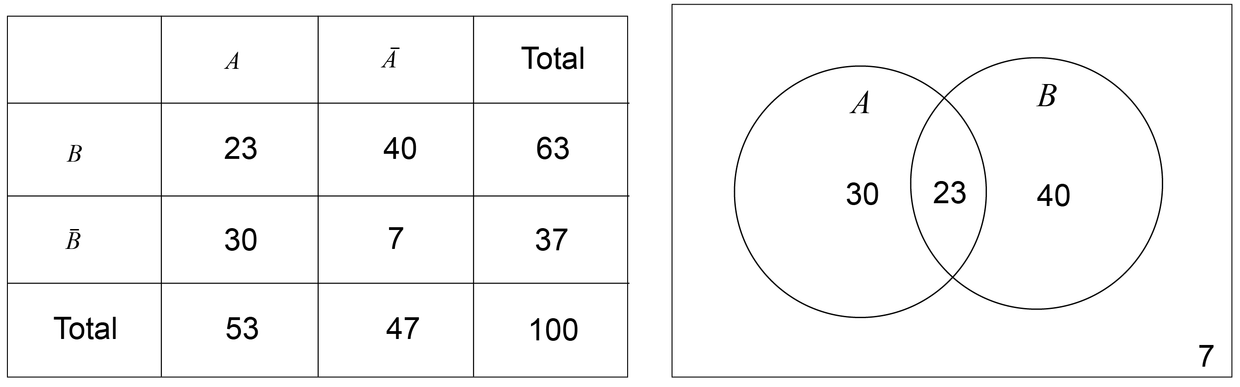
Image long description: In the table, row one includes column headers $$A$$, $$\bar{A}$$ and Total; row 2 includes row header $$B$$, 23, 40 and 63; row 3 includes row header $$B$$, 30, 7 and 37; and row 4 includes row header Total, 53, 47 and 100. In the Venn diagram, the 2 circles are labelled $$A$$ and $$B$$. Circle $$A$$ contains the number 30, circle $$B$$ contains the number 40 and the overlapping area contains the number 23. The number 7 sits outside the circles.

- Establish that $$P\left(A|B\right)=\frac{\left|A∩B\right|}{\left|B\right|}$$ when all outcomes are equally likely by restricting the sample space and event space, and hence $$P\left(A|B\right)=\frac{P(A∩B)}{P(B)}$$, provided $$\left|B\right|≠0$$
- Use the formulas for $$P(A|B)$$ to solve practical problems involving conditional probability
- Define two events to be independent if the occurrence of one event does not affect the probability that the other event occurs
- Explain that two events $$A$$ and $$B$$ are independent means $$P\left(A | B\right)=P\left(A\right)$$ and $$P\left(B | A\right)=P\left(B\right)$$, and show algebraically that if one of these formulas is true, then the other is also true
- Use the formula $$P\left(A|B\right)=\frac{P(A∩B)}{P(B)}$$, and the test $$P\left(A | B\right)=P\left(A\right)$$ for independence to prove that if two events are independent, then $$P\left(A∩B\right)=P\left(A\right)×P(B)$$, and to prove conversely that if $$P\left(A∩B\right)=P\left(A\right)×P(B)$$, then $$A$$ and $$B$$ are independent
- Solve practical problems involving independent events

Data
- Define a random variable as a variable whose value is the outcome of a random experiment
- Compare discrete random variables with continuous random variables, describe their differences, and give practical examples of each
Example(s):
The number of customers who arrive at the bank between two certain times is a discrete random variable. The time it takes for a bulb to burn out is a continuous random variable.

- Organise finite datasets using a table or a spreadsheet, listing the values, frequency, relative frequency, cumulative frequency, and cumulative relative frequency
- Graph the frequency, relative frequency, and cumulative frequency histograms and polygons of datasets, using spreadsheets or graphing applications, and identify the mode and median from the graphs, and from tables
- Use the relative frequency to estimate the probability of results in experiments

Outcomes and content for Year 12

Further graph transformations and modelling

Outcomes
A student:
- develops understanding and fluency in mathematics through exploring and connecting mathematical concepts, choosing and applying mathematical techniques to solve problems, and communicating their thinking and reasoning coherently and clearly MAO-WM-01
- uses algebraic and graphical techniques to analyse trigonometric functions MAV-12-01
- models, analyses and solves practical problems involving functions and their transformations MAV-12-02

Content

Transformations of trigonometric functions
- Use graphing applications to explore reflections, translations and dilations of, and confirm that the principles of transformations hold for, the trigonometric functions $$f\left(x\right)=\sin{x}$$, $$f\left(x\right)=\cos{x}$$ and $$f(x)=\tan{x}$$
- Apply the principles of transformations to graph transformations of the trigonometric functions $$f\left(x\right)=\sin{x}$$, $$f\left(x\right)=\cos{x}$$ and $$f(x)=\tan{x}$$, describe which transformations have been applied to $$y=f(x)$$ and determine the domain, range, horizontal translation, vertical translation, dilation factor, period and amplitude when applicable
- Solve equations and graphical problems involving transformations of the trigonometric functions $$f\left(x\right)=\sin{x}$$, $$f\left(x\right)=\cos{x}$$ or $$f(x)=\tan{x}$$, using graphing applications or otherwise, within a specified domain

Modelling with functions
- Model and solve problems involving periodic phenomena using transformations of the trigonometric functions $$f\left(x\right)=\sin{x}$$, $$f\left(x\right)=\cos{x}$$ or $$f(x)=\tan{x}$$, without the use of calculus
- Model and solve practical problems involving functions and their transformations, within the scope of the Mathematics Advanced course, using graphical and algebraic techniques
- Recognise that logarithmic scales are useful to represent a variable that ranges over a large set of values and explain when a logarithmic scale is suitable
- Use logarithmic scales to model and solve problems involving decibels (dB) in acoustics, seismic scales for earthquakes, magnitudes of stars and the pH scale in chemistry

Sequences and series

Outcomes
A student:
- develops understanding and fluency in mathematics through exploring and connecting mathematical concepts, choosing and applying mathematical techniques to solve problems, and communicating their thinking and reasoning coherently and clearly MAO-WM-01
- uses arithmetic and geometric sequences and series to model and solve problems MAV-12-03

Content

Sequences and series
- Define a sequence as an ordered list of objects
- Use the notation $$a_{n}$$, where $$n$$ is a positive integer, to represent the $$n$$th term of a sequence
- Distinguish between a finite sequence $$a_{1}, a_{2},…, a_{m}$$ that terminates at its $$m$$th term, for some whole number $$m≥1$$, and an infinite sequence $$a_{1}, a_{2},…$$ that never terminates
- Define the $$n$$th partial sum $$S_{n}$$ of a sequence $$a_{1}, a_{2},…$$ to be the sum of the first $$n$$terms of the sequence: $$S_{n}=a_{1}+a_{2}+…+a_{n}$$, for all whole numbers $$n≥1$$
- Define a series formally as the sum of the terms of an infinite sequence and use the notation $$a_{1}+a_{2}+a_{3}+…$$ for the series corresponding to the sequence $$a_{1},a_{2},a_{3}…$$
- Use summation notation to represent the sum of terms $$a_{i}$$ to $$a_{j}$$ of a sequence where $$j>i$$, $$\sum_{k=i}^{j}{a_{k}}=a_{i}+a_{i+1 }+a_{i+2}+ … + a_{j-1}+a_{j}$$
Example(s):
$$\sum_{k=1}^{5}{(2k+1)}=3+5+7+9+11$$.

Arithmetic sequences and series
- Define a sequence $$a_{n}$$ to be an arithmetic sequence, or arithmetic progression (AP), if every difference $$a_{n}-a_{n-1}$$ of successive terms is the same where $$n≥2$$, that is $$a_{n}-a_{n-1}=d$$ for some constant $$d$$ called the common difference
- Develop the formula $$a_{n}=a+(n-1)d$$ for the $$n$$th term of an AP, where $$a$$ is the first term and $$n≥1$$, and use it to solve problems
- Recognise that $$a_{n}$$ is a linear function of $$n$$ in an AP
- Develop the formula $$S_{n}=\frac{n}{2}\left(a+a_{n}\right)$$ for the $$n$$th partial sum of an AP, and use the formula to solve problems
- Develop the formula $$S_{n}=\frac{n}{2}\left[2a+\left(n-1\right)d\right]$$ for the $$n$$th partial sum of an AP, and use the formula to solve problems
- Apply the formulas for arithmetic sequences and their partial sums to model and solve growth and decay problems involving a quantity that is a linear function of time

Geometric sequences and series
- Define a sequence $$a_{n}$$ to be a geometric sequence, or geometric progression (GP), if every ratio $$\frac{a_{n}}{a_{n-1}}$$ of successive terms is the same where $$n≥2$$, that is $$a_{n}=ra_{n-1}$$ for some non-zero real number $$r$$ called the common ratio
- Develop the formula $$a_{n}=ar^{n-1}$$ for the $$n$$th term of a GP, where $$a$$ is the first term and $$n≥1$$, and use it to solve problems
- Recognise that $$a_{n}$$ is an exponential function of $$n$$ in a GP
- Prove by expansion $$\left(x-1\right)\left(x^{n-1}+x^{n-2}+…+x^{2}+x+1\right)=x^{n}-1$$for whole numbers $$n≥1$$
- Develop the formula $$S_{n}=\frac{a(1-r^{n})}{1-r}$$ for the sum of the first $$n$$ terms of a GP where $$r≠1$$, and use this formula to solve problems
- Examine the behaviour of $$a_{n}$$ and $$S_{n}$$ as $$n→∞$$ for a GP when $$\left|r\right|<1$$
- Develop the formula $$S_{∞}=\frac{a}{1-r}$$ for the limiting sum of a geometric series with $$\left|r\right|<1$$, and use this formula to solve problems
- Apply the formulas for geometric sequences and series to model and solve growth and decay problems where a quantity is an exponential function of time

Differential calculus

Outcomes
A student:
- develops understanding and fluency in mathematics through exploring and connecting mathematical concepts, choosing and applying mathematical techniques to solve problems, and communicating their thinking and reasoning coherently and clearly MAO-WM-01
- selects and applies differentiation methods to solve problems MAV-12-04

Content

Differentiation with exponential functions
- Apply the rules of differentiation to find the derivative of $$f\left(x\right)=ke^{ax}$$, where $$k$$ and $$a$$ are constants
- Use the chain rule to prove $$\frac{d}{dx}\left(e^{ax+b}\right)=ae^{ax+b}$$, where $$a$$ and $$b$$ are constants and $$a≠0$$
- Prove and use the formula $$\frac{d}{dx}\left(a^{x}\right)=(\ln{a})a^{x}$$, where $$a$$ is a constant and $$a>0$$
- Use the chain rule to differentiate functions of the form $$e^{f\left(x\right)}$$

Differentiation with logarithmic functions
- Use chain rule on the identity $$e^{\ln{x}}=x$$ to prove the formula $$\frac{d}{dx}\left(\ln{x}\right)=\frac{1}{x}$$ for the derivative of the natural logarithm function where $$x>0$$
- Prove and use the formula $$\frac{d}{dx}\left(\log_{a}x\right)=\frac{1}{x\ln{a}}$$, where $$a$$ is a constant and $$a>0$$
- Use the chain rule to differentiate functions of the form $$\ln{f\left(x\right)}$$

Differentiation with trigonometric functions
- Determine the formulas $$\frac{d}{dx}\left(\sin{x}\right)=\cos{x}$$and $$\frac{d}{dx}\left(\cos{x}\right)=-\sin{x}$$ informally by using the graphs of $$y=\sin{x}$$ and $$y=\cos{x}$$ and verify with graphing applications
- Use the rules of differentiation to show that $$\frac{d}{dx}(\tan{x)=\sec^{2}}{x}$$
- Use the rules of differentiation to find the derivatives of $$\operatorname{cosec}{x}$$, $$\sec{x}$$ and $$\cot{x}$$
- Use the chain rule to differentiate functions of the form $$\sin{f\left(x\right)}$$, $$\cos{f\left(x\right)}$$ and $$\tan{f\left(x\right)}$$

Using derivatives
- Apply the product, quotient and chain rules to differentiate functions of the form
$$f\left(x\right)g\left(x\right)$$, $$\frac{f\left(x\right)}{g\left(x\right)}$$ or $$f(g(x))$$, where $$f(x)$$ and $$g(x)$$ are any of the functions within the scope of the Mathematics Advanced course
Example(s):
Differentiate with respect to $$x$$: $$xe^{x}$$ and $$\sin^{2}{x}$$.

- Solve problems involving equations of tangents and normals to curves involving any of the functions within the scope of the Mathematics Advanced course

Integral calculus

Outcomes
A student:
- develops understanding and fluency in mathematics through exploring and connecting mathematical concepts, choosing and applying mathematical techniques to solve problems, and communicating their thinking and reasoning coherently and clearly MAO-WM-01
- solves problems involving indefinite and definite integrals MAV-12-05

Content

Primitive functions
- Define a primitive of a function $$f(x)$$ as a function $$F(x)$$ whose derivative $$F'\left(x\right)=f(x)$$ and recognise the process of finding the primitive as the reverse of differentiation
- Recognise that a function whose derivative is everywhere zero is a constant function
- Prove by differentiation that a primitive of $$f\left(x\right)=x^{n}$$ is $$F\left(x\right)=\frac{x^{n+1}}{n+1}$$, for all real $$n≠-1$$
- Prove by differentiation that if $$F(x)$$ and $$G(x)$$ are primitives of $$f(x)$$ and $$g(x)$$, and $$k$$ is a constant, then $$F\left(x\right)+G(x)$$ is a primitive of $$f\left(x\right)+g(x)$$, and $$kF(x)$$ is a primitive of $$kf(x)$$
- Recognise that primitives of a function $$f(x)$$ are not unique, and that any two primitives of $$f(x)$$ differ by a constant, so that if $$F(x)$$ is a primitive of $$f(x)$$, the general primitive of $$f(x)$$ is $$F\left(x\right)+C$$, for some constant $$C$$
- Determine the primitive of a given function $$f(x)$$, where $$f(x)$$ is a sum of functions of the form $$kx^{n}$$ for all real $$n≠-1$$
Example(s):
Determine the primitive function of $$f\left(x\right)=4x^{3}+x^{2}-5x+1$$ and $$f\left(p\right)=\frac{1}{\sqrt{p}}$$.

- Determine the primitive function for functions of the form $$f\left(x\right)={\left(ax+b\right)}^{n}$$, for all real $$n≠-1$$, where $$a$$ and $$b$$ are constants
- Use algebraic manipulation to express given functions in forms suitable for determining primitive functions
Example(s):
Determine the primitive function of $$g\left(r\right)=\frac{r^{5}-2r^{3}}{r^{2}}$$.

- Determine $$f(x)$$, given $$f'(x)$$ and an initial condition $$f(a)=b$$ where $$a$$ and $$b$$ are constants

The definite integral
- Examine for a function $$f(x)$$, which indicates the rate of change of a quantity, the meaning of $$\sum_{a}^{b}{f\left(x\right)Δx}$$, where the interval $$a≤x≤b$$ is divided into subintervals of length $$Δx$$, and describe $$\sum_{a}^{b}{f\left(x\right)Δx}$$ as an estimate of the total change in that quantity over the interval $$a≤x≤b$$
Example(s):
Describe the area under a velocity–time graph as representing a distance travelled; describe the area under a graph of daily snowfalls over a month as the total amount of snow that has fallen in that month.

- Consider the definite integral as $$\int_{a}^{b}{f(x)}dx=\lim_{Δx→0}{\sum_{a}^{b}{f\left(x\right)Δx}}$$, noting that this implies that the result of a definite integral will be negative when $$f\left(x\right)≤0$$ throughout the interval $$a≤x≤b$$
- Define informally that a function is continuous on the interval $$a≤x≤b$$ if it can be drawn between the two endpoints of the interval without taking the pen off the paper
- Graph the region between the continuous function $$y=f\left(x\right)$$ and the $$x$$-axis, where $$f\left(x\right)≥0$$ on the interval $$a≤x≤b$$
- Use a graphing application to compare different methods of approximating the area, $$A$$, of the region between the continuous function $$y=f(x)$$ and the $$x$$-axis, where $$f\left(x\right)≥0$$ on the interval $$a≤x≤b$$, by summing the areas of trapezia or rectangles each of width $$Δx=\frac{b - a}{n}$$ and approximate height $$f\left(x\right)$$ for any $$x$$ lying in its base, and observe the effect on the precision of the approximation of $$A$$ as the number $$n$$ of subintervals of $$a≤x≤b$$ increases, that is as $$Δx→0$$
Example(s):
Use a graphing application to approximate the area under the curve $$y=x^{2}$$ in the interval $$[0,1]$$ using sums of rectangles and compare the left-endpoint estimate, right-endpoint estimate and midpoint estimate.

- Evaluate the definite integral $$∫_{a}^{b}f\left(x\right)dx$$ by calculating areas using geometrical formulas, where the shape of $$f(x)$$ allows such calculations, in cases where $$f\left(x\right)≥0$$throughout $$a≤x≤b$$, $$f\left(x\right)≤0$$throughout $$a≤x≤b$$ or where $$f(x)$$ changes sign in the interval $$a≤x≤b$$
Example(s):
Find the value of $$\int_{0}^{2}{\sqrt{4-x^{2}}}dx$$ using geometric ideas.

The Fundamental Theorem of Calculus
- Consider the function defined by $$A\left(x\right)=\int_{a}^{x}{f\left(t\right)d}t$$ and use a graphing application to recognise that $$A(x)$$ is a primitive of $$f(x)$$
- Recognise the Fundamental Theorem of Calculus as $$\int_{a}^{b}{f}\left(x\right)dx=\left[F(x)\right]{b \atop a}=F\left(b\right)-F\left(a\right)$$ for a continuous function $$f$$ on the interval $$a≤x≤b$$ where $$F(x)$$ is any primitive of $$f\left(x\right)$$

Indefinite integrals
- Use the notation $$∫f\left(x\right)dx$$ for the general primitive of $$f\left(x\right),$$ called the indefinite integral of $$f\left(x\right)$$, so that $$∫f\left(x\right)dx=F\left(x\right)+C$$, for some constant $$C$$, where $$F(x)$$ is any primitive of $$f(x)$$
- Recognise integration as the process of finding the indefinite integral of a function
- Use the formula $$∫x^{n}dx=\frac{1}{n+1}x^{n+1}+C$$ for real $$n≠-1$$
- Use the identities $$∫\left(f\left(x\right)+g\left(x\right)\right)dx=∫f(x)dx+∫g(x)dx$$ and $$∫kf(x)dx=k∫f(x)dx$$ for primitives
- Prove by differentiation, and apply $$∫u^{n}\frac{du}{dx}dx=\frac{1}{n+1}u^{n+1}+C$$, where $$u$$ is a function of $$x$$, or $$∫f'\left(x\right){\left[f(x)\right]}^{n}dx=\frac{1}{n+1}{\left[f(x)\right]}^{n+1}+C$$, for real $$n≠-1$$
Example(s):
Find $$∫\left(4x+8\right){\left(x^{2}+4x-3\right)}^{3}dx$$.

Integration with exponential functions
- Establish and use the formula $$∫e^{x}dx=e^{x}+C$$
- Establish and use the formula $$∫e^{ax+b}dx=\frac{1}{a}e^{ax+b}+C$$, where $$a$$ and $$b$$ are constants and $$a≠0$$
- Establish and use the formula $$∫a^{x}dx=\frac{a^{x}}{ln a}+C$$, where $$a$$ is a constant and $$a>0$$
- Establish and use $$∫e^{u}\frac{du}{dx}dx=e^{u}+C$$, where $$u$$ is a function of $$x$$, or $$∫f^{'}\left(x\right)e^{f\left(x\right)}dx=e^{f\left(x\right)}+C$$
- Find primitives of functions involving exponential functions

Integration with logarithmic functions
- Derive and use the formula $$∫\frac{1}{x}dx=\ln{|x|}+C$$ where $$x≠0$$
- Establish and use the formula $$∫\frac{1}{ax+b}dx=\frac{1}{a}\ln\left|ax+b\right|+C$$, where $$a$$ and $$b$$ are constants and $$a≠0$$
- Establish and use $$∫\frac{u^{'}}{u}dx=\ln\left|u\right|+C$$, where $$u$$ is a function of $$x$$, or $$∫\frac{f^{'}\left(x\right)}{f\left(x\right)}dx=\ln{|f(x)|}+C$$, on a domain where $$f\left(x\right)≠0$$

Integration with trigonometric functions
- Establish and use the formulas $$∫\sin{x}dx=-\cos{x}+C$$, $$∫\cos{x}dx=\sin{x}+C$$ and $$∫\sec^{2}{x}dx=\tan{x}+C$$
- Establish and use indefinite integrals of the form $$∫f(ax+b)dx$$, where $$a$$ and $$b$$ are constants and $$a≠0$$, and $$f\left(x\right)=\sin{x}$$, $$f\left(x\right)=\cos{x}$$ and $$f\left(x\right)=\sec^{2}{x}$$
- Determine indefinite integrals of the form $$∫f'(x)\sin{f\left(x\right)}dx$$, $$∫f'(x)\cos{f(x)}dx$$ and $$∫f'(x)\sec^{2}{f(x)}dx$$

Areas and the definite integral
- Apply $$\int_{a}^{b}{f\left(x\right)}dx=F\left(b\right)-F\left(a\right)$$, where $$F(x)$$ is a primitive of $$f(x)$$, to calculate definite integrals and solve related theoretical problems involving functions within the scope of the Mathematics Advanced course
- Describe, in the case where $$f\left(x\right)≥0$$ for all values of $$x$$ in the interval $$a≤x≤b$$, the area bounded by the graph of the continuous function $$y=f(x)$$, the $$x$$-axis and the lines $$x=a$$ and $$x=b$$, as $$\int_{a}^{b}{f(x)}dx$$
- Recognise, in the case where $$f\left(x\right)≤0$$ for all values of $$x$$ in the interval $$a≤x≤b$$, the area bounded by the graph of the continuous function $$y=f(x)$$, the $$x$$-axis and the lines $$x=a$$ and $$x=b$$, as $$\left|\int_{a}^{b}{f(x)}dx\right|$$ or $$-\int_{a}^{b}{f(x)}dx$$
- Conclude, for a continuous function $$y=f(x)$$ on the interval $$a≤x≤b$$, that $$\int_{a}^{b}{f(x)}dx=$$ (area of regions between curve and $$x$$-axis lying above the $$x$$-axis) $$-$$ (area of regions between curve and the $$x$$-axis lying below the $$x$$-axis)
Example(s):
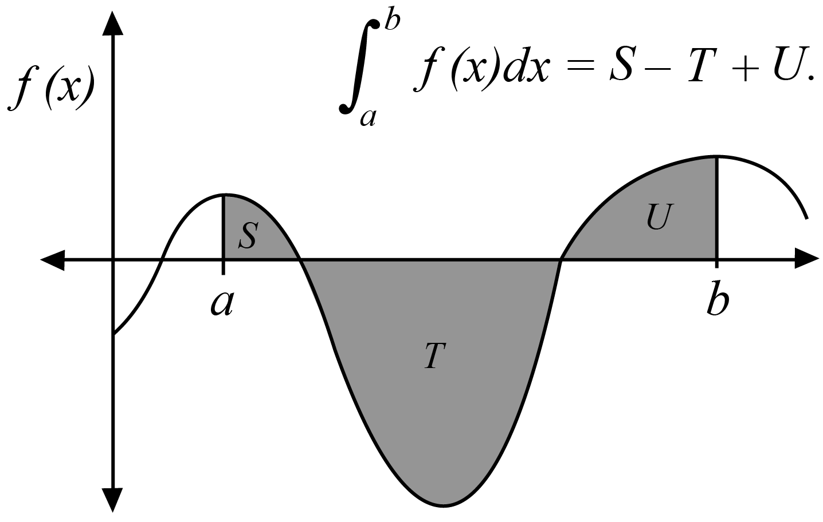
Image long description: A curve $$y=f(x)$$ starting at $$x=0$$ and $$y<0$$ and crossing the $$x$$-axis three times. The area between the curve and the $$x$$-axis from $$x=a$$ to $$x=b$$ is shaded. The area $$S$$ lies above the $$x$$-axis between $$x=a$$ and the second $$x$$-intercept. The area $$T$$ lies below the $$x$$-axis between the second and third $$x$$-intercepts. The area $$U$$ lies above the $$x$$-axis between the third $$x$$-intercept and $$x=b$$. The caption shows $$\int_{a}^{b}{f\left(x\right)dx}=S-T+U$$.

- Use definite integrals to solve problems involving the areas of regions bounded by the graph of the continuous function $$y=f(x)$$, the $$x$$-axis and the lines $$x=a$$ and $$x=b$$, in cases where $$f\left(x\right)≥0$$throughout $$a≤x≤b$$, $$f\left(x\right)≤0$$throughout $$a≤x≤b$$ or where $$f(x)$$ changes sign in the interval $$a≤x≤b$$, with or without the graph provided
- Use definite integrals to solve problems involving the areas of regions bounded by the graph of the continuous function $$y=f(x)$$, the $$y$$-axis and the lines $$y=a$$ and $$y=b$$, in cases where $$x≥0$$throughout $$a≤y≤b$$, $$x≤0$$throughout $$a≤y≤b$$ or where $$x$$ changes sign in the interval $$a≤y≤b$$ with or without the graph provided
- Use the fact that the graphs of $$y=a^{x}$$ and $$y=\log_{a}{x}$$ are reflections of each other in the line $$y=x$$ to solve problems involving areas between the $$x$$-axis or $$y$$-axis and a curve involving either an exponential or logarithmic function
- Recognise and use the result, where $$f(x)$$ is continuous on the interval $$a≤x≤c$$, $$\int_{a}^{b}{f\left(x\right)dx}+\int_{b}^{c}{f\left(x\right)dx}=\int_{a}^{c}{f\left(x\right)dx}$$ for all $$c$$ such that $$a≤b≤c$$
- Define and use the result $$\int_{a}^{b}{f\left(x\right)dx}=-\int_{b}^{a}{f\left(x\right)dx}$$, where $$f(x)$$ is continuous on the interval $$a≤x≤b$$
- Recognise and use symmetry, particularly odd and even functions, to simplify and solve integration problems
- Use the Trapezoidal rule to approximate integrals
Example(s):
Use the Trapezoidal rule with four trapezia to find an approximation for $$\int_{1}^{3}{\ln{x}dx}$$.

- Use an online computational application to evaluate definite and indefinite integrals involving functions within and beyond the scope of the Mathematics Advanced course
- Model and solve practical problems involving integrals and areas of regions bounded by a curve and the $$x$$-axis, or by a curve and the $$y$$-axis, involving functions within the scope of the Mathematics Advanced course
Example(s):
Find areas of shapes used in design; identify Lorenz curves, that is functions with the properties: $$f\left(x\right)$$ is differentiable on the interval $$0≤x≤1$$, $$f\left(0\right)=0$$ and $$f\left(1\right)=1$$, and $$f\left(x\right)≤x$$ for $$0≤x≤1$$ and evaluate the Gini coefficient $$G=2\int_{0}^{1}{\left[x-f(x)\right]dx}$$ for functions whose graphs are Lorenz curves.

Applications of calculus

Outcomes
A student:
- develops understanding and fluency in mathematics through exploring and connecting mathematical concepts, choosing and applying mathematical techniques to solve problems, and communicating their thinking and reasoning coherently and clearly MAO-WM-01
- applies calculus to graph functions and model and solve problems involving optimisation, rates of change and motion in a line MAV-12-06

Content

Turning points, inflections and curve-sketching
- Define a function $$f\left(x\right)$$to be differentiable at $$x=a$$ if $$\lim_{h→0}\frac{f\left(a+h\right)-f\left(a\right)}{h}$$ exists, that is if there is a non-vertical tangent to the curve at the point $$P\left(a,f\left(a\right)\right)$$ and recognise that if $$f\left(x\right)$$ is differentiable at $$x=a$$ then it is continuous at $$x=a$$
- Identify any values of $$x$$ where a function is continuous, but not differentiable, given either the equation of the function or its graph
Example(s):
The function $$y=f(x)$$ is given by $$f\left(x\right)=\left\{\begin{matrix}2-x, x<1 \\ x^{2}, x≥1\end{matrix}\right.$$. Determine if $$f(x)$$ is continuous and differentiable when $$x=1$$.

- Use repeated differentiation to find second derivatives of a function $$y=f(x)$$, denoting them by $$f''(x)$$ or $$\frac{d^{2}y}{dx^{2}}$$ or $$y''$$
- Analyse the stationary points of a function by testing values for $$f'(x)$$, then classify the stationary points as local minima or local maxima where gradients change around the point, or horizontal points of inflection where gradients have the same sign on both sides of the point
- Interpret the second derivative $$y''$$ as the gradient function of the first derivative $$y'$$, and deduce that if $$y''>0$$ the curve is concave up and if $$y''<0$$ the curve is concave down
- Define a point of inflection on a curve as a point where the concavity changes
- Analyse the value of $$f''(x)$$ either side of the roots of $$f''\left(x\right)=0$$, and use the resulting concavities to identify which zeroes of $$f''\left(x\right)$$ are points of inflection
- Use the second derivative to classify a stationary point as a local maximum, local minimum or a horizontal point of inflection
- Graph a function by determining local maxima and minima and points of inflection, horizontal and non-horizontal, considering any even or odd symmetry, the domain, any vertical asymptotes or other discontinuities, and where applicable, the behaviour of a function as $$x→±∞$$
Example(s):
Find the stationary points on the graph of $$y=x^{2}e^{x}$$ and determine their nature. Find any point(s) of inflection and graph the function.

- Graph $$y=f'(x)$$ and $$y=f''(x)$$ for a function $$y=f(x)$$, given only a graph of $$y=f(x)$$

Optimisation
- Define a global maximum of a function $$f(x)$$ to be a point $$P\left(a,f\left(a\right)\right)$$ on the graph where $$f\left(x\right)≤f(a)$$, for all $$x$$ in the domain, and define a global minimum similarly
Example(s):
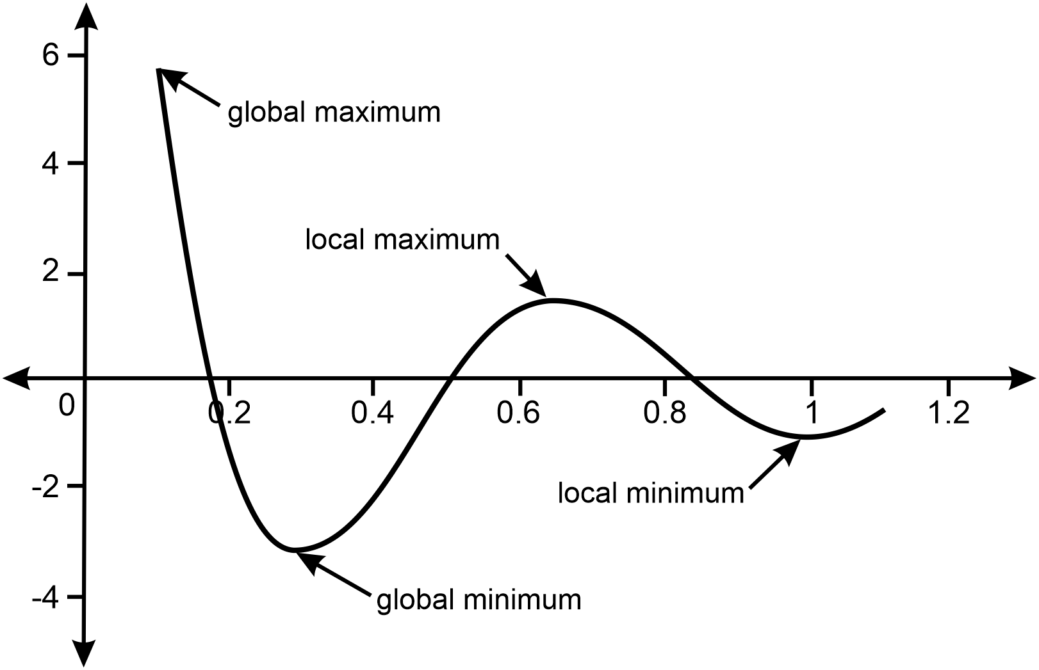
Image long description: The curve on the number plane shows an endpoint at $$(0.1, 6)$$ labelled global maximum. A minimum turning point lies below the $$x$$-axis at $$(0.3,-3.0)$$ and is labelled global minimum. A maximum turning point lies above the $$x$$-axis at $$(0.7, 2)$$ and is labelled local maximum. A minimum turning point lies below the $$x$$-axis at $$(1.0,-1.0)$$ and is labelled local minimum. The curve crosses the $$x$$-axis at approximately $$x=0.18$$, $$0.5$$ and $$0.82$$.

- Examine whether any discontinuities or endpoints of the domain on which $$f(x)$$ is being considered are points of maxima or minima
Example(s):
Recognise that $$y=\left|x\right|$$ is not differentiable at $$x=0$$, and that there is a local minimum at $$x=0$$.

- Model optimisation problems in a variety of contexts by defining variables, noting domain restrictions if necessary, and establishing functions to represent the relationship between variables
- Solve optimisation problems by using calculus to find local and global maxima and minima of differentiable functions, checking discontinuities of $$f'(x)$$ and endpoints of the domain if applicable
- Formulate conclusions to optimisation problems by evaluating solutions given the constraints of the domain

Rates of change
- Use differentiation to find and interpret the first and second derivatives, $$\frac{dQ}{dt}$$ and $$\frac{d^{2}Q}{dt^{2}}$$, in practical problems where a quantity $$Q$$ is a function of time $$t$$
Example(s):
A valve is slowly opened in a pipeline such that the volume flow rate $$R$$ varies with time according to the relation $$R=kt$$, $$(t>0)$$, where $$k$$ is a constant. Calculate the total volume of water that flows through the valve in the first 10 seconds if $$k$$ = 1.3 m³s^{–2} .

- Use integration to solve practical problems on the rate of change of a quantity $$Q,$$ where $$\frac{dQ}{dt}$$ or $$\frac{d^{2}Q}{dt^{2}}$$ is given as a function of time $$t$$, together with sufficient initial conditions
- Describe and examine the graphs of practical situations where the rate of change of a quantity is proportional to the quantity
- Explain that if the rate of change of a positive quantity $$Q$$ over time $$t$$ is proportional to the size of $$Q$$, then this may be represented by $$\frac{dQ}{dt}=kQ$$ where $$k$$ is the constant of proportionality, and if $$k>0$$ the quantity $$Q$$ is increasing at a rate proportional to the value of $$Q$$ at time $$t$$, while if $$k<0$$ the quantity $$Q$$ is decreasing at a rate proportional to the value of $$Q$$ at time $$t$$
- Verify by substitution that the function $$Q=Ae^{kt}$$ satisfies the relationship $$\frac{dQ}{dt}=kQ$$ with $$A$$ being the initial value of $$Q$$
- Recognise that the equation $$\frac{dQ}{dt}=kQ$$ where $$Q>0$$, and its solution $$Q=Ae^{kt}$$ represent exponential growth when $$k>0$$ and exponential decay when $$k<0$$
- Graph the function $$Q=Ae^{kt}$$, where $$k>0$$ and $$k<0$$ and $$A>0$$ and $$A<0$$, with and without graphing applications, and identify any asymptotes
- Model and solve growth and decay problems in various contexts using $$\frac{dQ}{dt}=kQ$$, $$Q=Ae^{kt}$$ and the graph of $$Q=Ae^{kt}$$ for $$t≥0$$, and justify conclusions in the context of the problem
- Determine the velocity and acceleration of a particle moving in a straight line given its displacement from a point as a function of time, and use the notation $$\frac{d^{2}x}{dt^{2}}$$ or $$\overset{¨}{x}$$ to represent acceleration
- Solve problems relating to the motion of a particle moving in a straight line, using both differentiation and integration to connect the concepts of displacement, velocity and acceleration

Random variables

Outcomes
A student:
- develops understanding and fluency in mathematics through exploring and connecting mathematical concepts, choosing and applying mathematical techniques to solve problems, and communicating their thinking and reasoning coherently and clearly MAO-WM-01
- solves problems involving discrete probability distributions, continuous random variables and the normal distribution MAV-12-07

Content

Discrete random variables
- Use the relative frequencies of discrete random variable datasets to estimate the probabilities that the random variable $$X$$ takes each of its values, and explain why these estimated probabilities add to 1
- Denote the probability that the discrete random variable $$X$$ takes the value $$x$$ by $$P(X=x)$$, or by $$P(x)$$ if the discrete random variable $$X$$ is understood
- Define a discrete probability distribution to be the set of values $$x$$ taken by a discrete random variable $$X$$, together with the probabilities $$P(x)$$ that $$x$$ is the outcome of the experiment
- Define a discrete random variable to be uniformly distributed if it has finitely many values, all with the same probability, and use it to model random phenomena with equally likely outcomes
- Recognise the mean, or expected value, $$μ$$ or $$\text{E}\left(X\right)$$, of a discrete random variable $$X$$ as a measure of centre for its distribution
- Generate and use the formulas $$\text{E}\left(X\right)=μ=ΣxP(x)$$ and $$Var\left(X\right)=σ^{2}=Σ{\left(x-μ\right)}^{2}P\left(x\right)=Σx^{2}P\left(x\right)-μ^{2}$$ for the random variable $$X$$, where $$Var\left(X\right)$$ is the variance and $$σ$$ is the standard deviation of the distribution
- Recognise that the variance is an expected value because $$\text{Var}\left(X\right)=\text{E}\left({\left(X-μ\right)}^{2}\right)$$
- Generate a probability distribution for a given discrete random variable and represent the probability distribution in graphical and tabular form
Example(s):
The probability distribution for the random variable $$X$$ which takes on values 1, 2, 3, and 4, each of which are equally likely is represented using a table:
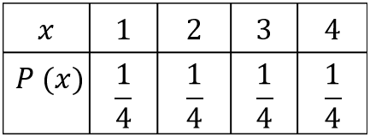
Image long description: The first row of the table has the values of $$x$$, $$1$$, $$2$$, $$3$$ and $$4$$. The second row of the table has the values of $$P(x)$$, and $$\frac{1}{4}$$ repeated in the remaining cells.

- Solve problems involving probabilities, expectation and variance of discrete random variables

Continuous random variables
- Estimate the probability that a continuous random variable falls in some interval using relative frequencies and histograms obtained from data
- Recognise that the probability of a particular value for a continuous random variable is 0 and hence that $$P\left(a<X<b\right)=P\left(a≤X<b\right)=P\left(a<X≤b\right)=P\left(a≤X≤b\right)$$ since $$P\left(X=a\right)=P\left(X=b\right)=0$$ when $$X$$ is a continuous random variable
- Define the cumulative distribution function (CDF), $$F\left(x\right)$$, as the probability of a random variable, $$X$$, having values less than or equal to $$x$$, so $$F\left(x\right)=P\left(X≤x\right)$$ and $$P\left(a≤x≤b\right)=F\left(b\right)-F(a)$$
- Recognise that the cumulative distribution function, $$F(x)$$, is non-decreasing for all $$x$$ in its domain, and graph cumulative distribution functions, given a formula for $$F(x)$$, with and without graphing applications
- Define a probability density function (PDF), $$f\left(x\right)$$, for a random variable $$X$$ with cumulative distribution function $$F\left(x\right)$$ as $$f\left(x\right)=F'(x)$$ and recognise that $$P\left(a<X<b\right)=\int_{a}^{b}{f(x)}dx$$
- Recognise the properties of a probability density function: $$f(x)≥0$$ for all $$x$$ in the domain of $$f\left(x\right),$$ and $$\int_{a}^{b}{f{(x})dx}=1$$ if the domain of $$f(x)$$ is $$[a,b]$$, or $$\int_{-∞}^{∞}{f{(x})dx}=1$$ if the domain of $$f(x)$$ is all real $$x$$
- Apply the properties of a probability density function to solve problems and justify conclusions
- Find the mode from a given probability density function
- Obtain the cumulative distribution function using the formula $$F\left(x\right)=\int_{a}^{x}{f\left(t\right)dt}$$ where $$f\left(x\right)$$ is a given probability density function defined on the interval $$\left[a,b\right]$$
- Determine and use the probability density function $$f\left(x\right)=\frac{1}{b-a}$$ for a continuous uniform distribution for a random variable $$X$$ taking values in the interval $$[a,b]$$
- Use a cumulative distribution function to calculate the median and quartiles for a continuous random variable
- Find the probability density function from a given cumulative distribution function
- Generate the expression for the expected value of a continuous random variable, $$E\left(X\right)=μ=\int_{a}^{b}{xf\left(x\right)dx}$$, where the probability density function $$f\left(x\right)$$ is defined on the interval $$[a,b]$$
- Generate the expression for the variance of a continuous random variable, $$\text{Var}\left(X\right)=E\left(X^{2}\right)-μ^{2}=\int_{a}^{b}{x^{2}f\left(x\right)dx}-μ^{2}$$, where the probability density function $$f\left(x\right)$$ is defined on the interval $$[a,b]$$
- Evaluate the expected value and the variance of a continuous random variable, where the probability density function $$f\left(x\right)$$ is defined on the interval $$[a,b]$$, that involve integration of functions within the scope of the Mathematics Advanced course
- Evaluate the expected value and the variance of a continuous random variable, where the probability density function $$f\left(x\right)$$ is defined on the interval $$[a,b]$$, that involve integration of functions beyond the scope of the Mathematics Advanced course using an online computational application

The normal distribution
- Identify the normal distribution as a continuous probability distribution that is used to model many naturally occurring phenomena
- Identify the graph of the probability density function of a normal distribution, the normal curve, as an ‘ideal’ bell-shaped curve, symmetrical about its mean which is equal to its mode and median, and as having most values concentrated about the mean
- Identify contexts that can be approximately modelled by a normal random variable
Example(s):
The heights of a group of students can be modelled by a normal random variable.

- Use the notation $$X∼N\left(μ,σ^{2}\right)$$ to represent a normally distributed random variable that has mean $$μ$$ and standard deviation $$σ$$
- Represent probabilities associated with the normal distribution by areas of shaded regions under the normal curve, which may extend to $$±∞$$
- Apply the empirical rule to make judgements and solve problems involving probabilities of normally distributed data: that for normal distributions, approximately 68% of data lie within one standard deviation of the mean, approximately 95% within two standard deviations of the mean and approximately 99.7% within three standard deviations of the mean
- Use graphing applications to explore the normal distribution, graph the probability density function $$f\left(x\right)=\frac{1}{σ\sqrt{2π}}e^{-\frac{({x-μ)}^{2}}{2σ^{2}}}$$, verify the empirical rule and graph the cumulative distribution function
- Recognise features of the normal curve, and identify the global maximum and points of inflection
- Distinguish between a standard normal distribution with mean 0 and standard deviation 1, and the non-standard normal distribution with mean $$μ$$ and standard deviation $$σ$$
- Define the $$z$$-score, or standardised score, by the formula $$z=\frac{x-μ}{σ}$$, where $$μ$$ is the mean and $$σ$$ is the standard deviation, and $$x$$ is an observed value of a random variable
- Interpret the $$z$$-score as the number of standard deviations a score lies above or below the mean
- Use $$z$$-scores to compare scores from different sets of data and justify conclusions
- Use $$z$$-scores to identify probabilities of events less or more extreme than a given outcome and solve problems using tables for the standard normal distribution
- Solve problems involving finding the mean or standard deviation of a normal random variable given the probability of an event less or more extreme than a given outcome
- Use $$z$$-scores to make judgements related to probabilities of certain events or given sets of data assuming an underlying normal distribution

Financial mathematics

Outcomes
A student:
- develops understanding and fluency in mathematics through exploring and connecting mathematical concepts, choosing and applying mathematical techniques to solve problems, and communicating their thinking and reasoning coherently and clearly MAO-WM-01
- models and solves problems to make informed decisions about financial situations MAV-12-08

Content

Reducing balance loans
- Recognise a reducing balance loan algebraically as a compound interest loan with periodic repayments
- Examine the effect of varying the interest rate and repayment amount on the time taken to repay a loan, with or without digital tools or by using a given graph
- Solve problems that involve reducing balance loans by calculating the total amount paid, equal periodic repayments, the amount still owing and the time taken to repay the loan

Annuities
- Identify an annuity as either an investment account with regular, equal contributions and interest compounding at the end of each period, or as a single sum investment from which regular equal withdrawals are made
- Define and model the future value of an annuity as the sum of all the payments, together with the interest they have earned
- Examine the effect of varying the amount initially invested, the value of the periodic payment, the interest rate and the duration of the annuity on the total value of the investment, using digital tools
- Solve problems involving annuities in which payments are made at the end of each time period and the future value of an annuity is calculated at the end of one of these periods using the formula for the sum of the first $$n$$ terms of a geometric sequence

Assessment

Course standards
Course standards are comprised of syllabus standards and performance standards. Syllabus outcomes and content form the syllabus standards that describe what students are expected to know, understand and do. Performance standards, including the Common Grade Scale for Preliminary courses, HSC Performance Band Descriptions and Achievement Level Descriptions (for HSC courses with grades only) describe how well students have achieved in relation to syllabus standards. Performance standards are used to report student achievement on NESA credentials.

Common Grade Scale for Preliminary courses
Stage 6 – Year 11
The Common Grade Scale for Preliminary courses provides generic, holistic descriptions for performance at each of the 5 grade levels. It is used to report student achievement in Year 11 courses in all NSW schools.

Performance Band Descriptions for Mathematics Advanced
Stage 6 – Year 12
HSC performance band descriptions summarise the knowledge, understanding and skills typically demonstrated by students at each band level in a particular course. NESA uses these holistic descriptions to report a student's overall level of achievement in an HSC course.

Band 6
A student who performs at this level typically:
- demonstrates extensive knowledge, understanding and skills appropriate to the course
- integrates and applies mathematical concepts, skills and techniques consistently and accurately in a range of familiar and unfamiliar situations
- selects and applies a wide range of strategies to solve a variety of multi-step mathematical problems
- constructs and analyses mathematical models to solve problems in a variety of situations
- communicates reasoning and justification effectively, using appropriate mathematical language, notation, diagrams and graphs.

Band 5
A student who performs at this level typically:
- demonstrates thorough knowledge, understanding and skills appropriate to the course
- integrates and applies mathematical concepts, skills and techniques accurately in familiar and unfamiliar situations
- selects and applies a range of strategies to solve a variety of multi-step mathematical problems
- constructs and analyses mathematical models to solve problems
- communicates reasoning and justification using appropriate mathematical language, notation, diagrams and graphs.

Band 4
A student who performs at this level typically:
- demonstrates sound knowledge, understanding and skills appropriate to the course
- uses mathematical concepts, skills and techniques in familiar and some unfamiliar situations
- selects and uses strategies to solve mathematical problems
- interprets mathematical models to solve problems
- communicates reasoning and justification using mathematical language, notation, diagrams and graphs.

Band 3
A student who performs at this level typically:
- demonstrates basic knowledge, understanding and skills appropriate to the course
- uses mathematical concepts, skills and techniques in familiar situations
- solves simple mathematical problems
- interprets some mathematical models
- communicates reasoning using mathematical language, notation, diagrams and graphs.

Band 2
A student who performs at this level typically:
- demonstrates elementary knowledge, understanding and skills appropriate to the course
- uses some mathematical concepts, skills and techniques to solve simple familiar problems with limited accuracy
- uses some mathematical language, notation, diagrams and graphs.

Band 1
Performance reported as Band 1 indicates that the minimum standard expected was not demonstrated.

School-based assessment
Schools are required to develop an assessment program for each Year 11 and Year 12 course. NESA provides information about the responsibilities of schools in developing assessment programs in course-specific assessment requirements and in the Assessment Certification Examination (ACE) rules and requirements.

Year 11 Mathematics Advanced school-based assessment
Stage 6 – Year 11
Schools are required to submit to NESA a grade for each student based on their achievement at the end of the course.
Teachers use professional, on-balance judgement to allocate grades based on the Common Grade Scale for Preliminary courses.
Teachers consider all available assessment information, including formal and informal assessment, to determine the grade that best matches each student’s achievement at the end of the course.
See Assessment Certification Examination (ACE) rules and requirements for further information.

Assessment programs must reflect course components and weightings
The course components and component weightings for Year 11 are mandatory.
Course component | Weighting %
Knowledge and understanding of course content | 50
Skills in Working mathematically | 50

Schools may determine specific elements of their assessment program
Schools have authority to determine the number, type of task and the weighting allocated to an assessment task. Schools may also follow the sample assessment programs provided by NESA.
Sample assessment program
NESA's sample Year 11 formal school-based assessment program for Mathematics Advanced is:
- 3 assessment tasks, including:
  - a formal written examination
  - a weighting for any individual task of 20% to 40%.
Some students with disability may require adjustments in order to access assessment opportunities and demonstrate achievement of outcomes.

Year 12 Mathematics Advanced school-based assessment
Stage 6 – Year 12
NESA requires schools to submit a school-based assessment mark for each Year 12 student who completes this course. Formal school-based assessment tasks should reflect the syllabus outcomes and content. The mark submitted by the school provides a summation of each student’s achievement measured at several points throughout the course.
A school’s program of school-based assessment includes both mandatory and non-mandatory elements.
See Assessment Certification Examination (ACE) rules and requirements for further information.

Assessment programs must reflect course components and weightings
The course components and component weightings for Year 12 are mandatory.
Course component | Weighting %
Knowledge and understanding of course content | 50
Skills in Working mathematically | 50

Schools may determine specific elements of their assessment program
Schools have authority to determine the number, type of task and the weighting allocated to an assessment task. Schools may also follow the sample assessment programs provided by NESA.
Sample assessment program
NESA's sample Year 12 formal school-based assessment program for Mathematics Advanced is:
- 4 assessment tasks, including:
  - a formal written examination
  - a weighting for any individual task of 10% to 40%.
Some students with disability may require adjustments in order to access assessment opportunities and demonstrate achievement of outcomes.
Formal school-based assessment in this course should focus on the Year 12 outcomes. The Year 11 course is assumed knowledge and may be assessed.

Sample assessment schedules
Stage 6
- Sample assessment schedule Year 11
- Sample assessment schedule Year 12: A
- Sample assessment schedule Year 12: B

Sample assessment task notifications
Stage 6
- Sample formal assessment task notification: Year 11 (Working with functions)
- Sample formal assessment task notification: Year 12 (Applications of probability)

HSC examinations
The external HSC examination measures student achievement in a range of syllabus outcomes.
The external examination and its marking relate to the syllabus by:
- providing clear links to syllabus outcomes
- enabling students to demonstrate the levels of achievement outlined in the Performance Band Descriptions
- applying marking guidelines based on criteria that relate to the quality of the response
- aligning performance in the examination each year to the standards established for the course.
Examination questions may require students to integrate knowledge, understanding and skills developed through studying the course.
The Year 11 course is assumed knowledge for the Year 12 course.
Some students with disability may be eligible for disability provisions when completing the HSC examination.
The examination will be based on the Mathematics Advanced Year 12 course and will focus on the Year 12 outcomes. The Mathematics Advanced Year 11 course will be assumed knowledge for this examination and may be examined.

Mathematics Advanced HSC examination specifications
Stage 6 – Year 12
The examination will consist of a written paper worth 100 marks.
Time allowed: 3 hours plus 10 minutes reading time.
A reference sheet will be provided.
NESA-approved calculators may be used.
The paper will consist of two sections.
Section I (10 marks)
- There will be objective-response questions to the value of 10 marks.
Section II (90 marks)
- Questions may contain parts.
- There will be 37 to 42 items.
- At least two items will be worth 4 or 5 marks.

HSC Mathematics Advanced – annotated sample examination materials
Stage 6 – Year 12
- HSC Mathematics Advanced – annotated sample examination materials
- Mathematics Advanced – HSC reference sheet

Further information
Stage 6 – Year 12
- Assessment in Stage 6
- Principles of effective assessment
- Assessment in practice
- School-based assessment requirements
- Adjustments to assessment for students with disability
- Life Skills
- Assessment Certification Examination (ACE) website

